2025 HBOT4KYVETS, Inc., ANNUAL REPORT
TO THE STATE OF KENTUCKY
Veterans Hyperbaric Oxygen Therapy (HBOT) Treatment Program
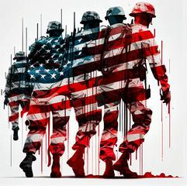
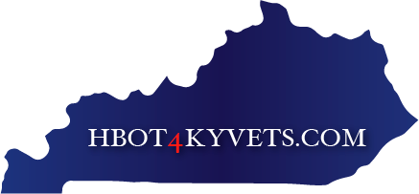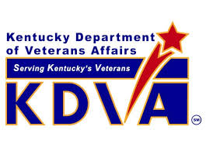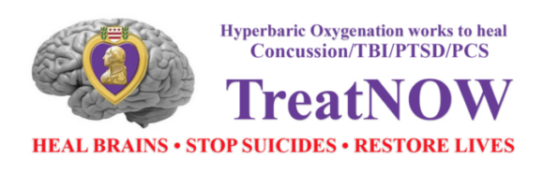
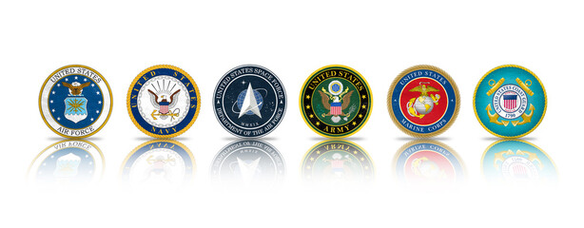
THE REPORT IS PROVIDED TO THE KENTUCKY GOVERNOR, KDVA COMMISSIONER, GOVERNORS ADVISORY BOARD (GAB), COMMITTEE ON VETERANS, MILITARY AFFAIRS, AND PUBLIC PROTECTION (VMAPP), KENTUCKY U.S. MILITARY RESERVE AND NATIONAL GUARD COMPONENTS

HBOT4KYVETS, Inc Annual Report is distributed in accordance with KDVA Memorandum of Understanding (MOU) dated May 9, 2024, under Progress Reporting

Prepared By
Mr. Eric Koleda, USAF Veteran, Director and Co-Founder, HBOT4KYVETS, Inc.

Collaboration Members
Mrs. Eunice Ray, Director and Co-Founder HBOT4KYVETS, Inc.
Dr. Linda Jeffrery, Ed. D, Director HBOT4KYVETS, Inc.

Report Review Committee Members
Dr. Robert Beckman, PhD, USAF Veteran, Executive Director and Co-Founder, TreatNOW
Mr. Ken Clodfelter, CEO Cutting Edge Business Solutions, GE Black Belt
Dr. John Meyers, Psy.D. ABN, ABPdN, Meyers Neuropsychological Services (ANAM Analysis)
Dr. Mark Lynn, O.D., Lynn Family Sports Vision and Training (Right Eye Analysis)
Army Brigadier General (Ret) James Bauerle, The Military Veterans Coalition of Indiana
Mr. James Hooker, USN (Ret), Coordinator North Carolina Veteran HBOT Program
Mr. Pat Fox, US Army Veteran, Director, HBOT4KYVETS, Inc.

TABLE OF CONTENTS
Page
Table of Contents……………………………………………………………………………………………………….. 3
Letter to the Kentucky Leadership………………………………………………………………….…………… 4-5
Executive Summary……………………………………………………………………………………………………… 6
Program History…………………………………………………………………………………………………………… 7
Demographics of TBI/PTSD Veteran Applicants……………………………………………………………. 8-10
Program Testing and Treatment Results
History of HBOT Medical and Treatment Results……………………………………………… 10
HBOT4KYVETS, Inc Program and Protocol………………………………………………………… 10-11
HBOT4KYVETS, Inc Program Testing Introduction…………………………………………….. 12
Test Battery Descriptions…………………………………………………………………………………. 12-13
ANAM Data Results…………………………………………………………………………………………. 13-17
ANAM Analysis Results……………………………………………………………………………… ……. 18
Right Eye Tests and Results……………………………………………………………………………… 19
Drug and Alcohol Testing…………………………………………………………………………………. 20
Combat Exposure Scale, DVBIC TBI Screening Tool, DAST, MAST……………………… 20-26
Overall HBOT Treatment Testing Summary………………………………………………………. 26
National and Kentucky Veteran Testimonials………………………………………………………………. 26-30
2024/2025 KDVA Monthly and Annual Metrics and Measurements
Financials………………………………………………………………………………………………………… 30-32
2024-2025 KDVA Monthly and Annual Advocacy and Outreach Metrics……………………… 32-33
2024-2025 KDVA Monthly and Annual Education Reporting Metrics………………………….. 33-34
Public Relations and News Media……………………………………………………………………………….. 34
State and National Legislation…………………………………………………………………………………….. 34-36
Preventing Suicides and Restoring Families…………………………………………………………………. 36-37
Amplifying Results and Evidence…………………………………………………………………………………. 37-38
Broad Support Among Veterans for Off Label Treatments Survey………………………………… 38-40
Appendix A, B, C ..……………………………………………………………………………………………………….. 41-46

Letter to the Kentucky Leadership
As President of HBOT4KYVETS, Inc, a registered 501 (C)(3) nonprofit (EIN # 83-0608537), I am honored to present our first annual report on the Kentucky Veteran Hyperbaric Oxygen Therapy (HBOT) Program. The past year, our mission to provide life-saving treatment to Veterans suffering from TBI, PTSD, and other war related injuries has delivered transformational and consistent results, as reflected in the attached report.
Since 2020, HBOT4KYVETS, Inc., has provided HBOT treatments to TBI/PTSD Veterans with either state funding, private donations, and or our own $30K self-funding for Veterans under KRS 217.930-942 (See Appendix B). It has offered Veterans renewed purpose in life. Our research has identified thousands of Veterans across the country and in our Commonwealth in desperate need of this therapy. Many struggling since Vietnam and subsequent conflicts in Iraq and Afghanistan. These efforts reveal a growing demand for accessible, effective care for TBI/PTSD and related injuries. Despite our success, the number of Veteran on debilitating drugs and or alcohol, homeless, unemployed, non-employable, depressed and dealing with suicide ideation continues to sustain at 20+ suicides per day across the country and here in the Commonwealth. An estimated 110 Veteran suicides per year in Kentucky.
The Kentucky Department of Veterans Affairs (KDVA), through our Memorandum of Understanding (MOU) executed on May 9, 2024, provide monthly financial accounting, state funding distribution, and collect our monthly Advocacy and Outreach and Education Reporting Metrics and Measurements. Under the leadership of Commissioner Allen and Deputy Commissioner Renaud, the staff have consistently demonstrated their timely support and efforts for this treatment program. This is testimony to the long-standing KDVA role of supporting the men and woman who have served in uniform in our Commonwealth.
Program results demonstrate remarkable improvement in treated Veterans, including reduced TBI/PTSD symptoms, better TBI cognitive function, and decrease or elimination of suicidal ideation. Testimonials from Veterans and families underscore HBOT’s life changing impact across the country which may be viewed here: https://www.youtube.com/@treatnowdotorg/videos. Specific Kentucky treated Veteran testimonials may be viewed in the Veteran testimonial section of the report.
We have pursued federal funding through the VA and US Congress, but this has proven to be a bureaucratic challenge. Over 1,200 hospitals across the country who provide HBOT for FDA, CMS, and Tricare approved uses like non-healing wounds, which reduce Diabetic Foot Ulcers (DFU) by 74%. The VA continues to avoid fully adopting of this approved lifesaving treatment. Over 796,340 DFU Veterans have died in the VA system from DFUs and Lower Limb Amputations (LLA) from 2001 to 2022 according to July 2022 VA data report. Given this resistance, it is highly unlikely the VA will address TBI/PTSD with HBOT without an act of Congress mandating its standard. The 12 states enacting HBOT legislation and the state legislative bodies across the country can help by engaging with the US Congressional delegation and request federal assistance for our Veterans.
The Lexington and Louisville VA leadership has been adversarial to the Kentucky state approved and funded TBI/PTSD HBOT program. This is despite numerous multiple efforts over 12 months to partner at any level of the program, including referring Veterans for treatment. This is a zero cost to the VA. We were informed by the VA Lexington leadership that regardless of all 50 states enacting HBOT laws, they will not be participating unless mandated under federal law.
In March of this year, a Lexington VA medical Nurse Practitioner threaten a TBI/PTSD Veteran in our state approved and funded treatment program of losing all his VA medical benefits if he continued in our treatment program. This violated numerous federal and state statues in addition to medical ethical codes. We are attempting to address this incident through the VA in Washington as attempts to work with the local Lexington VA leadership have failed to address the issue with us.
This event occurred despite compelling 27-peer reviewed and published medical studies and trials demonstrating HBOT safety and efficacy since 2007. Twelve states have enacted HBOT legislation, seven funding over $32 million in treatments, while HBOT is a standard of care for the Israeli Defense Force (IDF). The 1990 Textbook of Military Medicine recommends HBOT for blast wave TBIs for over 35-years. The federal failure highlights the urgent need for state leadership, as Kentucky and 11 other states have demonstrated by setting a national example in addressing these unmet Veteran medical treatment needs.
To meet the rising demand, HBOT4KYVETS, Inc. have proactively contracted to expand the hospital capability of delivering HBOT to Kentucky Veterans under KRS 217.930-942 in three key Veteran markets of Louisville, Lexington/Winchester, and Hopkinsville. Most hospitals have embraced the state statue for helping Veterans. We are counting on adding a hospital in Elizabethtown adjacent to Fort Knox in 2025, the fourth largest state Veteran market and another hospital in Louisville.
Secretary of Health and Human Services Robert F. Kennedy recently announced his plan to implement alternative treatment approvals through the FDA including HBOT. Congressman Gregory Murphy, MD (R-NC) said in an interview, if it is offered to the Israel military personnel why is our VA not offering it, “I believe it is medical malpractice not to offer HBOT for TBI/PTSD/Concussion to our Veterans.”

Our treatment network of community hospitals across the Commonwealth coupled with the state support is highly effective. We will re-engage with the Kentucky legislative body to bring awareness of the seven of twelve states who have funded and their high success with HBOT treatments of Veterans in Kentucky and across the country.
This program honors our TBI/PTSD Veterans by providing the care they earned and deserve. The KDVA, Kentucky hospitals and test facility partnerships is making a difference in the lives of Veterans and their families across the Commonwealth. Eliminating Veteran suicides is a priority and paid HBOT treatment is helping to migrate us towards that goal. Thank you for your steadfast support and consideration.
Sincerely,

Eric W. Koleda
President and Co-Founder
502-938-1300 Cell
Ewk7405@aol.com
Physical Address: 9462 Brownsboro Road, #217, Louisville, KY 40241
Executive Summary
Since 2020, HBOT4KYVETS, Inc. has been delivering Hyperbaric Oxygen Therapy (HBOT) to Kentucky Veterans diagnosed with Traumatic Brain Injury (TBI), often accompanied by PTSD, depression, anxiety, and suicidal ideation. In 2024, Kentucky allocated $1.5 million over two years to support this lifesaving treatment program under HB 64/KRS 217.930-942. HBOT has yielded transformational results for Veterans previously underserved by traditional medical systems.
From July 1, 2024, to June 2025, 59 Veterans applied to the program, 16 were approved and began treatment, and 11 completed therapies since program inception in 2020. Currently ten remain in the treatment program. All treated Veterans reported significant improvement in cognitive symptoms. Evaluations included ANAM and Right Eye assessments, and 64% of treated Veterans since 2020 have returned to school or the workforce. The average cost per Veteran was $15,020, and approximately $509,674 remains of the current physical year budget. The original budgeting projection was 50 TBI Veterans to be treated per year or approximately 4 per month which would have equated to the $750,000. We have treated an average of 1.3 Veterans per month.
Results indicate HBOT significantly reduces symptoms of TBI, enhances cognitive performance, and decreases or eliminates suicidal ideation. All sixteen have seen significant improvements in their cognitive related symptoms (see Veteran testimonials page 26-29). Treated Veterans consistently showed improved reaction time, memory, emotional stability, and visual tracking. Testimonials underscore life-changing impacts, from reduced PTSD symptoms to improved quality of life. Nationally, HBOT is supported by over 27 peer-reviewed studies, and 12 states have enacted legislation to promote HBOT, provide and or fund treatments. There were over 900 successful patient/veteran participants in the studies and trials.
A total of 115 TBIs were indicated with the 59 applications or an average of 1.9 TBIs per veteran. A total of 66% of applicants were ether Army or Marines based on their “boots on the ground” mission and exposure to blast force wave TBIs. Average TBI Veteran age was 47 with 11.2 years of military service.
Despite VA non-participation and bureaucratic resistance, HBOT4KYVETS, Inc. has built a statewide treatment network of hospital partners in Louisville, Lexington/Winchester, Hopkinsville, and Jeffersonville, IN, with plans to expand in 2025. With continued support, this program can serve more Kentucky Veterans, reduce the state’s 110 annual Veteran suicides, and provide a national model for treating the invisible wounds of war in a national and statewide HBOT hospital network of HBOT treatment facilities. Over 1,200+ hospitals nationwide provide HBOT services to their communities.
HBOT is a safe, effective, and cost-efficient solution to the growing crisis of untreated TBI/PTSD among Veterans. With sustained state funding, advocacy, and expansion, Kentucky can continue to lead in delivering the care Veterans have earned and deserve. This consistency underscores HBOT’s reliability as a treatment option, offering meaningful mental health and quality-of-life benefits for veterans and service members. Additionally, HBOT serves as a valuable suicide prevention strategy and a critical tool for enhancing military force retention.
Program History
In 2015 we began the legislative process of migrating HBOT treatment forward as a protocol for Kentucky Veterans based on my late brother-in-law Colonel Ronald D. Ray. Colonel Ray was an invisible wounded Vietnam Marine decorated combat Veteran who was diagnosed with TBI/PTSD. His un-diagnosed and mis-diagnosed TBIs were not properly identified until early 2015. Colonel Ray’s bio highlights include 30-years of Marine Corp military service for which he was awarded two Silver Stars for gallantry, a Bronze Star with Combat “V” for Valor, the Purple Heart, the Vietnamese Cross of Gallantry and the Vietnamese Honor Medal. Colonel Ray was a law Partner with Greenbaum, Doll and McDonald for 15 years. In 1984 during President Reagan administration, he was appointed the first Deputy Assistant Secretary of Defense for the Guard and Reserves. He received the prestigious Pentagon National Eagle Award from the National Guard Association.
To remember and never forget the last full measure of devotion of the more than 1,058 Kentuckians that never returned from Vietnam, Colonel Ray founded and served as the first Chairman of the Kentucky Vietnam Veterans Memorial Fund, which privately raised more than one million dollars to build and dedicate, in 1988, a unique granite sundial as a memorial to Vietnam Veterans in Frankfort, Kentucky. Colonel Ray would go on to serve on two Presidential Commissions. President Bush in 1990 appointed Colonel Ray to the American Battle Monuments Commission and in 1992 the Commission on Assignment of Woman in the Armed Forces. Colonel Ray’s full Biography may be viewed here.
In 2018, we were successful in enacting “The Colonel Ronald D. Ray Traumatic Brain Injury and Treatment Act” under HB 64, (KRS 217.930-942), opening the HBOT chambers to Veterans suffering from TBI in the Commonwealth.
On July 6, 2020, Colonel Ray succumbed to his Vietnam invisible combat wounds. His legacy survives in our treatment program helping heal and restore fellow combat veterans and ensuring their long-term health is not impacted from their un-diagnosed and mis-diagnosed invisible brain wounds.

In 2022 we were successful in enacting House Concurrent Resolution (HCR) 40 with the support of the Joint Executive Council of Veterans Organizations (JECVO) urging the US Congress to provide HBOT funding for TBI/PTSD Veterans.

In 2024, the Kentucky Legislature body passed HB 1 funding HBOT4KYVETs, Inc with $1.5 million over the two-year budget cycle through June 30, 2026. This funding is for pre and post testing and actual HBOT treatments in locations around the state. HBOT4KYVETS, Inc has developed a network of community-based hospital HBOT Wound Care Center treatment facilities operating in Winchester, Louisville, and Hopkinsville, Kentucky and Jeffersonville, IN. We plan on adding two additional hospitals in 2025. In the twelve states which have enacted HBOT legislation, Kentucky is currently the sole state administering HBOT to Veterans through a community-based hospital network. It demonstrates to the country and the VA that state community based medical support is feasible with the existing HBOT infrastructure of over 1,200 hospitals across the country providing HBOT services for the 14 FDA, CMS and Tricare approved HBOT treatment indications (See Appendix C).

Demographics of TBI/PTSD Veteran Applicants Seeking HBOT Treatments
Veterans seeking to attain Kentucky state approved and funded testing and HBOT treatments are required to meet the following minimum criteria to include but not limited to the following:
- Be a veteran who has served in one of the six armed services
- Be a Veteran resident of the state of Kentucky
- Provide a written diagnosis of TBI in accordance with KRS 217.934 (See Appendix B)
A total of 59 Veterans submitted electronic applications via HBOT4KYVETS.com website online process during the 2024-2025 reporting period. The demographic data contained herein is captured from the electronic application process each Veteran submits and will be used to further enhance our treatment program.
The breakdown of the Veteran applications is as follows:
- 56 male and 3 females submitted electronic applications
- 3 active-duty, 1 active Guard, 1 active Reserve and 54 veterans
- Service branches submitting HBOT applications include the following in the chart below:

Service Branch | Number of Veterans | Percentage of Total | Comments
Army | 31 | 52.5% | Includes Reserves and National Guard
Marines | 8 | 13.6% | Includes Reserves
Navy | 7 | 11.9% | 2 SEALS and Navy Reserves included
USAF | 10 | 16.9% | Includes Active-Duty Combat Controllers and Pararescue
USAF/Army | 2 | 3.4% | Multi-Service
Army/USCG | 1 | 1.7% | Multi-Service
Total | 59 | 100.0%

- 66% of applicants were ether Army or Marines based on their “boots on the ground” mission and exposure to blast force wave TBIs
- 12 did not have a written TBI diagnosis who were diagnosed with PTSD only but had all the symptoms of TBIs. Under KRS 217.934 these Veterans did not qualify for the treatment program. Note: KY is the only state of the 12 which does not treat PTSD Veterans with HBOT. We are working to get these Veterans re-examined and diagnosed, and we will work to amend KRS 217.934 to include PTSD Veterans based on new published medical data
- 5 applicants (8.5%) reside in Indiana and were referred to the Indiana HBOT treatment program
- 1 applicant resided in Missouri and was referred to a HBOT treatment program in Missouri
- 12 applicant TBIs (20.3%) were not service related. One of these Veterans has completed application requirements and will enter treatments in June
- A total of 115 TBIs were indicated with the 59 applications or an average of 1.9 TBIs per veteran
- The highest number of TBIs indicated with two Veterans were 7 and 10 each respectively. Numerous Veterans experienced TBIs over and above the diagnosed 1-2 TBIs but did not report those during service or did not realize until later they experienced a TBI. None have been re-examined via MRI or brain scans in the VA to validate actual number of TBIs they may have experienced. Note: Majority of TBI/PTSD Veterans have issues with being in an MRI machine for 30-45 minutes due to the noise and or claustrophobia issues associated with TBI/PTSD symptoms
- 18 Veterans served under Special Operations Command or 31%
- 36 served during Operations Iraqi Freedom (OIF) and 35 during Operation Enduring Freedom (OEF), with numerous Veterans overlapping and serving in multiple deployments in both theaters and operations
- TBI Veterans seeking HBOT treatments identified our program through the following outlets as shown in the chart below:
Outlet | # of Veterans | Percentage of Total
News Media | 18 | 30.5%
Other | 16 | 27.1%
Fellow Veteran | 14 | 23.7%
Social Media | 11 | 18.7%
Total | 59 | 100.0%

- Five Veterans had received HBOT previously or 8.5%
- The chart below reflects how most of the TBIs occurred based on Veteran submittals.
- Note: Over 70,000 IEDs exploded over the 21 years in the Iraq and Afghanistan conflicts.

Type TBI Induced | Number of TBI Veterans | Percent of Veterans
IED induced, blast induced, or Loss of Consciousness (LOC) | 39 | 66.0%
RPG, Heavy Weapon, Fall Thrown or Blown | 15 | 25.5%
Residual Symptoms | 5 | 8.5%
Total | 59 | 100.0%

- 34 Veterans are taking some level of prescription medications at time of application or 58% Note: Clinical study results indicated Veterans reduce their prescription medications by 50-90%.
- 17 indicated they had some level of previous cognitive testing completed including ANAM or 28.8%. We are attempting to attain TBI Veteran previous ANAM testing but it must be requested through their local VA MD Primary Care Physicians. Requests are normally fulfilled within 24 hours where records are retained in San Antonio if requests are received. We have been unsuccessful in getting the VA to submit record requests or the Veterans receiving their prior testing results.
- For all 59 TBI applicants a total of 660.5 years of military service or an average of 11.2 years per Veteran. Longest serving was 25 years and shortest was 2 years.
- Average age for all applicants was 47 years. Four were Vietnam era Veterans with average age of 78. Excluding the four Vietnam era Veterans the mean average age is 41.7 years.
Program Testing and Treatment Results
History of HBOT Medical and Treatment Results
HBOT4KYVETS, Inc provides HBOT testing and treatments through a statewide network of approved medical service providers and in accordance with KRS 217.930-942 since 2018. There have been 27 clinical studies and trials completed since 2007 across the entire US and each study and trial may be viewed her.
An outcome of these 27 multifaceted trials and studies are two HBOT peer reviewed and published meta-analysis articles in the Frontiers of Neurology, one of the country’s leading medical journals. The Systematic Review and Dosage Analysis: Hyperbaric Oxygen Therapy Efficacy in Mild Traumatic Brain Injury Persistent Post Concussion Syndrome by Dr. Paul G. Harch, MD, March 16, 2022 may be viewed here. This is a summary review of 11 of the 27 trials and studies demonstrating the safety and efficacy of HBOT treatments for mild TBIs.
The Systematic Review and Dosage Analysis: Hyperbaric Oxygen Therapy Efficacy in the Treatment of Post Traumatic Stress Disorder by Dr. Paul G. Harch, MD, May 30, 2024, may be viewed here. This is a summary review of 8 of the 27 trials and studies demonstrating the safety and efficacy of HBOT treatments for PTSD.
In the 1990 Textbook of Military Medicine, under The Management of Primary Blast Injury, Figure 9-10, Page 313, states “For evidence of Arterial Air Embolism and evidence of exposure to BLAST EXPOSURE, Definitive Therapy in Hyperbaric Chamber” is recommended. Now 35 years in the DoD medical textbook recommending treating concussions/TBIs with HBOT.
HBOT4KYVETS, Inc Program and Protocol
Veterans interested in receiving HBOT testing and treatment through HBOT4KYVETS, Inc program must begin by completing an electronic application on our website at HBOT4KYVETS.com. Simple click on “SIGN UP FOR TREATMENTS” in the big red block on the first page in the lower left corner. This begins the initial process.

Eligibility Requirements:
- Veterans are required to submit documents to validate their military service to include one of the following documents
- For Veterans a copy of your DD 214
- For active Reserve Veterans a copy of your DD 256
- For National Guard Veterans, a copy of your NGB 22
- If active duty, copy of their military ID
- Copy of Kentucky driver’s license to reflect you are a resident of the state of Kentucky
- Once documents are validated, a HBOT4KYVETS, inc. Treatment Agreement and the Health Insurance Portability and Accountability (HIPPA) Form is required to be read, signed and returned. Outlines our program and provides us access to treatment and testing data.
- Copy of the Veterans written medical diagnosis of TBI in accordance with KRS 217.934 (1) (See Appendix B).
Applicant and Approval Process:
- Once all documents are received, pre-cognitive testing is scheduled and conducted (ANAM, Right Eye, and a bank of computer-based tests).
- Pre Drug and Alcohol Testing is scheduled and completed (usually a week before treatments are to commence)
- Veteran is scheduled for an interview with HBOT treatment facility Medical Doctor to determine eligibility after review of individual medical history; they are then cleared to start HBOT treatments. A prescription for HBOT is provided.
- Veteran is scheduled into HBOT treatments
Treatment Protocol
Hyperbaric Oxygen Therapy (HBOT) is conducted in a pressurized FDA approved hyperbaric oxygen mono- chambers of varying manufactures under strict medical supervision. The protocol is designed to maximize safety and effectiveness for patients undergoing treatment. Key elements include:
- Duration of Each Session: Each daily session Monday-Friday, is 60 minutes duration at 1.5 atmospheres absolute (ATA) pressure at full pressure, plus 8-15 minutes for ascent and descent in chamber
- Medical Grade Oxygen-Patients receive 100% medical grade oxygen for therapeutic purposes
- Supervision and Monitoring- a trained, certified and qualified HBOT chamber technician are present throughout treatment sessions. A medical doctor is available to monitor patients’ health
- Vital Signs Monitoring: Patients vital signs are checked and monitored with each treatment
This comprehensive HBOT treatment protocol is at one of the lowest treatment pressures of all FDA, CMS, or Tricare approved indications. Treatments administered in hospital Wound Care Centers providing safe, consistent, and effective therapy tailored to the Veterans specific needs. Stand-alone facilities in Kentucky should meet the same current standards the hospital Wound Care Centers meet who are part of the HBOT4KYVETs, Inc, treatment program.
HBOT4KYVETS, Inc Program Testing Introduction
Since 2020, HBOT4KYVETS, Inc has been providing Hyperbaric Oxygen Therapy (HBOT) as an adjudicated therapeutic intervention for military personnel experiencing Traumatic Brain Injury (TBI), Post Traumatic Stress Disorder (PTSD), and associated symptoms including but not limited to depression, suicidal ideation, and anxiety. Recognized for its ability to enhance oxygen delivery to the human body, reduce inflammation, and support brain repair, HBOT offers a proven approach to addressing the complex health challenges faced by the military and in the general population.
This report presents an analysis of data collected through standardized test batteries, providing critical insights into the impact of HBOT on symptoms and quality of life for these service members. By evaluating outcomes over multiple years-spanning since 2007, coupled with the current results, the report contributes to the growing body of evidence supporting HBOT as an effective treatment for military related TBI/PTSD invisible wounded brains.
Findings consistently demonstrate that HBOT is a highly effective intervention for military personnel experiencing PTSD, Post Concussion Syndrome (PCS), depression, anxiety, and suicidal ideation. Each cohort has shown significant improvements in key metrics, particularly in PCS and anxiety. This consistency underscores HBOT’s reliability as a treatment option, offering meaningful physiological, mental health, and quality-of-life benefits for Veterans and service members. Additionally, HBOT serves as an invaluable suicide prevention strategy and a critical tool for enhancing military force retention by greatly reducing or eliminating suicide ideation in treatment subjects (see 27 clinical trial and study results).
Test Battery Descriptions
These tests are administered to determine the effects of HBOT on symptoms and quality of life among military personnel with mild TBI (mTBI) and PTSD. These tests measure the number and severity of the Veterans symptoms prior to beginning HBOT treatments and after 40 or more HBOT treatments. Tests include the FDA cleared and DoD approved Automated Neuropsychological Assessment Metrics (ANAM), FDA approved Right Eye, 3 Question DVBIC TBI Screening Tool, Combat Exposure Scale, Michigan Alcoholism Screening Test (MAST), and The Drug Abuse Screening Test (DAST).
- FDA Cleared and DoD Approved ANAM-Automated Neuropsychological Assessment Metrics-is an FDA cleared, and DoD approved computer-based neurocognitive assessment tool patented by Vista LiveScience’s, Inc from Colorado for the US Army. ANAM is used by the DoD to establish the brain baseline capability of the military personnel prior to deployment into combat arenas. ANAM has a three-decade lone history of use in the basic applied research as well as clinical practice. Over 350 peer-reviewed publications demonstrate its effectiveness in assessing cognition and measuring cognitive change. ANAM is used to measure the cognitive effects of stressful, extreme, or hazardous conditions; to quantify the effects and progress of neurological and other medical disorders; and to measure the effect of mild traumatic brain injury and sports concussion on cognitive function. In this application a Coree Battery set was used, comprised of 7 neurocognitive performance-based tests, as well as subtests reflecting mood scores. ANAM is used in assess the likelihood that a change in symptom reporting is reliable and clinically meaningful compared to military personnel sample as well as their own pre-treatment baseline.
- FDA Cleared Right Eye-Unlike traditional eye tracking tests that focus only on basic movement or alignment, Right Eye looks at the subtleties of eye motion, offering a comprehensive view of your visual system's performance. After a concussion or brain injury, patients often experience visual disturbances and difficulties with eye movement control. Right Eye’s technology can detect subtle changes in eye movement patterns, aiding in diagnosing and monitoring recovery. Thirty years of scientific research proves that eye movement behavior abnormalities are associated with at least 30 neurological disorders, including TBI. Saccades appear to be a reliable measure of brain dysfunction following Traumatic Brain Injury (TBI). Chronic low-level blast exposure has been linked with neurological alternation and TBI biomarkers. Impaired smooth-pursuit eye movements (SPEM) are often associated with TBI as reported in their May 2022 study.
- Combat Exposure Scale (CES)-is a 7-item self-report measure that assesses wartime stressors experienced by combatants. Respondents are asked to reply based on their exposure to various combat situations, such as firing rounds at the enemy and being on dangerous duty. The CES was developed to be easily administered and scored and is useful in both research and clinical settings. The total CES score (ranging from 0 - 41) is calculated by using a sum of weighted scores, which can be classified into one of five categories of combat exposure ranging from "light" to "heavy." Scoring instructions are included with the measure.
- DVBIC TBI Screening Tool-the purpose of this screen is to identify service members who may need further evaluation for mild traumatic brain injury (mTBI). Screen should be used with service members who were injured during combat operations, training missions or other activities. A service member who endorses an injury [Question 1], as well as an alteration of consciousness [Question 2 A-E], should be further evaluated via clinical interview because he/she is more highly suspect for having sustained an MTBI or concussion. The mTBI screen alone does not provide diagnosis of mTBI. A clinical interview is required. All Veterans are required to have a written TBI diagnosis to enter the program.
- Drug Abuse Screening Test (DAST)-is a 10-item brief screening tool that can be administered by a clinician or self-administered. Each question requires a yes or no response, and the tool can be completed in less than 8 minutes. This tool assesses drug use, not including alcohol or tobacco use, in the past 12-months.
- Michigan Alcoholism Screening Test (MAST)- The MAST screening tool is a 25-question test that is used to help identify an alcohol dependency. Questions included in MAST may be related to: risks associated with drinking patterns, neglect of responsibilities, loss of control, and other topics. As mentioned earlier, this test alone should not be used to self-diagnose a problem.
ANAM Data Results

ANAM DATA ANALYSIS
The data discussed in this analysis are four subjects gathered between the end of 2024 and 2025, each was tested prior to beginning the HBOT therapy and again following the completion of HBOT therapy. Subjects were tested with the Automated Neuropsychological Assessment Metrics (ANAM). It should be noted that the number of individual data sets is small (n=4) this limitation prevented some more detailed statistical analysis.

TESTING RESULTS BACKGROUND

A review of literature finds that a decrease in emotional distress is associated with a reduction in suicidality in military traumatic brain injured (TBI) veterans. Harch et al. (2017) used a group of 30 veterans with a history of TBI. Subjects were given a detailed evaluation including neurocognitive testing, questionnaires and SPECT imaging. Follow up testing at the conclusion of treatment with HBOT showed an improvement in cognitive performance as well as a decrease in emotional distress. Individuals also reported having less suicidality; 83% of subjects with suicidal ideation and 75% of subjects with panic attacks experienced a reduction or cessation in suicidal ideation or panic attacks after treatment.
The Shytle et al. (2019) article is a series of three case studies with use of HBOT. In these three studies there was commonality in the findings. First, there were significant cognitive deficits as well as emotional distress present at the pretreatment assessment. Following treatment, the post treatment assessment showed a uniform improvement in cognition as well as a decrease in emotional distress. This was particularly noted in case number two, which had initially reported moderate levels of suicidality and had a complete remission of suicidality following HBOT treatment.
In the Stanley et al. (2017) study, a total of 149 military service members were referred for evaluation/treatment of a suspected head injury. Self-report measures included the Suicidal Behaviors Questionnaire-Revised (SBQ-R), Automated Neuropsychological Assessment Metrics (ANAM), anger and depression subscales, and Behavioral Health Measure-20 depression subscale. Findings indicated suicidality was associated with anger and depression and that the reduction in emotional distress showed a reduction in suicidality.
References:
Harch PG, Andrews SR, Fogarty EF, Lucarini J, Van Meter KW. Case control study: hyperbaric oxygen treatment of mild traumatic brain injury persistent post-concussion syndrome and post-traumatic stress disorder. Med Gas Res. 2017 Oct 17;7(3):156-174. Doi: 10.4103/2045-9912.215745. PMID: 29152209; PMCID: PMC5674654.
Stanley I.H, Joiner T.E, Bryan C.J. (2017). Mild traumatic brain injury and suicide risk among a clinical sample of deployed military personnel: Evidence for a serial mediation model of anger and depression. J Psychiatric Res.
84:161-168. Doi: 10.1016/j.jpsychires.2016.10.004. Epub 2016 Oct 7. PMID: 27743528.
Shytle RD, Eve DJ, Kim S-H, Spiegel A, Sanberg PR, Borlongan CV. Retrospective Case Series of Traumatic Brain Injury and Post-Traumatic Stress Disorder Treated with Hyperbaric Oxygen Therapy. Cell Transplantation.
2019;28(7):885-892. Doi:10.1177/0963689719853232
ANAM Veteran Testing Low Participation Number
ANAM development is guided by public and private sector research. Early research versions of ANAM were developed in the U.S. Department of Defense. This work was patented by the U.S. Army and exclusively licensed for development and commercialization to benefit the military and the public. Through its Technology Transition program, the U.S. Army licensed ANAM and it has been deployed since 2008. ANAM has been used by some of the world’s most prestigious scientific organizations including NASA, which uses ANAM-based WINSCAT to assess neurocognitive status. ANAM has a long and continuous history of research in the Department of Defense, including sports concussion studies at West Point and Traumatic Brain Injury (TBI) studies during Ft. Bragg Paratrooper training. Through these and other programs, nearly two million ANAM test sessions have been collected.

For all service members deployed from 2008 forward, the DoD began testing all members. The DoD established the capability to consistently and continuous access to baseline testing results and generation of summary reports 24-hours per day, 7-days a week per DoD 6490.13, Public Law 104-191 (also known as the “Health Insurance Portability and Accountability Act). Reference (h) compliant capabilities for intra-agency and interagency sharing of neurocognitive assessment testing data, including requests from the Veterans Health Administration (VHA). Several Veterans in our treatment program elected to seek ANAM results and elected not to test directly with HBOT4KYVETS, Inc. resulting in lower ANAM test participants. Their ANAM results have not been attained as of this writing.

The majority of TBI Veterans served during the initial deployment of ANAM and were tested pre and post deployment but we have been unsuccessful in attaining test results through the VHA for the individual Veterans. As a TBI/PTSD Veteran, he/she may requests copies of their ANAM and neurocognitive test assessments by having the VHA/DoD medical doctor call or e-mail the Neurocognitive Assessment Branch helpdesk and request a copy of my ANAM results at (855)-630-7849 or e-mail at usarmy.jbsa.medcom.mbx.otsg-anam-baselines@health.mil. These requests are routinely made and ANAM results are provided to Veterans within 24 hours based on the helpdesk feedback we received. The requests are only fulfilled to individual Veterans if coordinated through the VHA or DoD medical doctors.

The following analysis was performed using all 4 of the subjects from this dataset.
SCORES
Chart #1
Kentucky 2025 HBOT Programs ANAM Scores for 4 Veterans
Pre HBOT Post HBOT
1
2
3
4
5
6
7
1= Simple Reaction Time, 2= Code Substitution Learning, 3= Procedural Reaction Time,
4= Mathematical Processing, 5= Matching to Sample,
6= Code Substitution Delayed, 7= SimpleReaction Time Repeated

Chart #2
Kentucky 2025 HBOT Programs ANAM Scores for 4 Veterans*
Pre HBOT Post HBOT

Anger Anxiety Depression Fatigue Restlessness Sleepiness
SCORES
*All 4 veterans experienced a decrease in negative mood indicators shown in Chart #2 above. This outcome taken together with an increase in positive mood shown in Chart #3 below, is correlated with reduced suicidality.
Chart #3
Kentucky 2025 HBOT Programs ANAM Scores for 4 Veterans*
Pre HBOT Post HBOT

 | Happiness | Vigor

*All 4 Veterans experienced an increase in positive mood as shown in Chart #3 above. This outcome taken together with a decrease in negative mood indicators as shown in Chart #2, is correlated with reduced suicidality.
SCORES
2025 ANAM ANALYSIS RESULTS

Four military veterans were treated by HBOT; each had a pre-assessment (Baseline) prior to beginning HBOT treatment and a post-assessment after HBOT. The tests and mood scales that are given in the ANAM shows that there was improvement in all scores from pre to post assessments across all tests of the ANAM. Especially noted is the improvement in negative emotions such as anxiety, depression and anger scores.

Lower scores indicated less anxiety, depression and anger. This is important given the work of Stanley, et al (2017), Harch et al. (2017) and Shytle et al. (2019) which reported that there was a compelling relationship between the presence of depression and anger and suicide. All three studies showed that a higher presence of depression and anger with a history of TBI was associated with more suicidal thoughts and attempts. Post HBOT reduced suicidality was reported as a result of reduced anger and depression and other negative emotions along with increases in positive emotions. The pre and post assessments showed reduced suicidality indicators with improved positive mood (Happiness and Vigor) and less negative mood (Anger, Anxiety, Depression, Restlessness and Fatigue).

Data from the 4 Kentucky HBOT program subjects showed improvement in cognitive performance in improved attention and concentration along with improvement in reasoning tasks. This improvement was especially noted in Simple Reaction Time, Code Substitution – Learning, Procedural Reaction Time, Code Substitution – Delayed and Simple Reaction Time Repeated.
A Paired Samples statistic could not be reliably performed due to the limited number of subject data sets.

Right Eye Testing and Results
Right Eye is an FDA-cleared, eye tracking system that supports the identification of visual tracking impairments in just minutes. The Right Eye Sensorimotor System™ evaluates how your eyes and brain work together. By analyzing eye movements, this technology helps diagnose and manage various conditions, from vision-related issues to brain health. This state-of-the-art system uses a high-speed camera to track eye movements. Patients watch a video, and as their eyes move, Right Eye captures detailed data that is analyzed to identify potential issues. It’s a non-invasive and quick test that provides valuable insights into your visual and neurological health.

In conducting Right Eye Analysis, four basic assessments are conducted which include the following:

- Fixation-The eyes ability to lock onto a target and hold focus
- Pursuits-the eyes ability to follow a moving target and work together
- Saccades-the eyes ability to move quickly to look at a target
- Processing-the brains ability to process the information the eyes are seeing

When patients experience a concussion/TBI, the Vestibular-Ocular System is damage in about 95% of all patients. The Vestibular-Ocular system is the way your eyes and brain communicate about what you see. If after a TBI, you are having problems it is very probable that your Bestibular-Ocular system is damaged. In TBI HBOT Veteran patients, we have conducted Right Eye initial tests prior to HBOT as foundation and during the treatment process to assess measurable changes in the Vestibular-Ocular system that we know will measure the healing and rehabilitation process.

Seven Veterans were assessed based on more than two tests being completed. The following results are shared.

Spec Ops 1-2024- From his ﬁrst visit on 9/9/2024 to his last visit on 3/10/25 he showed an improvement on his processing speed as well as his ability to control his vertical and horizontal saccades.
USAF 1-2025- From his ﬁrst visit on 12/18/2024 to his last visit on 4/17/2025 he had a large
improvement on his vertical and horizontal saccades as well as his processing ability.
Army 3-2024- We saw him ﬁve times from 8/12/24 to 2/17/25. He has had a major improvement in ﬁxation, tracking, saccades and processing.
Marine 3-2024- We have seen him 4 times from 10/10/24 to 5/28/25. He is showing better quality of eye movement as well as more controlled saccades and tracking.
Spec Ops 2-2023- He has been seen from 3/19/24 to 1/22/25 and his biggest changes
have been in his horizontal and vertical saccades.
Marine 1- 2024- We have seen him three times from 8/12/24 to 12/3/24. He has had a dramatic increase in his horizontal and vertical saccades as well as his processing speed.
Army 2-2024- We have seen him three times from 9/12/24 to 3/17/25 and have found a
much faster processing as well as better speed on saccades

All treated Veterans showed improvements. The biggest verbalized improvement is their ability to walk outside without wearing sunglasses due to the high sensitivity to light in the eyes with TBI patients.

Drug and Alcohol Testing
Every single TBI Veteran entering the HBOT treatment program is required to be 10-panel drug and alcohol tested prior to commencing treatments. This is a requirement of HBOT4KYVETS, Inc to ensure the safety of Veterans/patients while receiving HBOT treatments. The drug and alcohol testing service are contracted through Any Lab Test Now, Shelbyville Road Plaza, 4600 Shelbyville Rd, Suite 306, Louisville, KY 40207 in Louisville and through Jennie Stuart Medical Center Hospital, 320 West 18th Street, Hopkinsville, KY 42240.
The 10-panel drug screening includes the following substances:
Oxycodone (OXY)
Opiates (OPI)
Methamphetamine (MET)
Methadone (MTD)
MDMA (Ecstasy)
Marijuana (THC)
Amphetamine (AMP)
Benzodiazepines (BZO)
Buprenorphine (BUP)
Cocaine (COC)

Testing positive does not automatically exclude Veterans, but they would have to complete a drug rehabilitation program and or test negative over several test periods before they could be allowed into the program. If the Veterans have a prescription for any of the drugs tested positive, consultation with the medical staff at the designated HBOT treatment facility is required to make an assessment if they may receive HBOT treatments. Veterans sign a HBOT4KYVETS, Inc Treatment Agreement prior to commencing the HBOT treatment program and under item “J” agree to drug and alcohol testing initially, randomly or if requested by the medical staff while in the treatment program.

The ETB or Ethyl Glucuronide is used for the alcohol testing. Both the alcohol and drug panel tests are normally administered the week prior to commencing their initial HBOT screening and beginning treatments. The drug and alcohol testing are required as many TBI/PTSD Veterans have been either over medicated and prescribed or may be self-medicating to reduce or manage pain related cognitive and physical symptoms.
No Veteran applicants have failed the drug or alcohol testing as of this date which would have prevented them from participating in the treatment program.
HBOT4KYVETS, Inc Treatment Program Results
Combat Exposure Scale (National Center for PTSD, http://www.ptsd.va.gov)
The following responses were recorded from a total of 10 TBI Veterans. A bank of 7 questions is included in the questionnaire below. The responses below reflect exposure to blast, small and large arms fire, IEDs, RPGs and or air support dropping ordnance as well as high frequency level of exposure to the above of 4-7+ months at a time.
- Did you ever go on combat patrols or have other dangerous duty and 80% responded yes.
- Where you ever under enemy fire and 70% responded yes.
- Where you ever surrounded by the enemy and 50% responded yes
- What percentage of soldiers in your unit were KIA, wounded, or MIA and 80% responded 1-50% of the time it occurred.
- How often did you fire rounds at the enemy and 60% responded 3-51+ times
- How often did you see someone hit by incoming or outgoing rounds and 50% responded 3-50+ times.
- How often were you in danger of being injured, killed, pinned down, overrun, ambushed or near miss and 70% responded 3-51+ times
- The seven questions in the Combat Exposure Scale are listed with responses below.

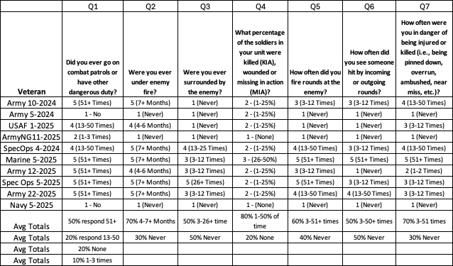

3 Question DVBIC TBI Screening Tool (www.DVBIC.org, mirecc.va.gov)

The following responses were recorded from a total of 10 TBI Veterans. A bank of 5 questions is included in the questionnaire herein below. The TBI screening tool provides insight into both injuries sustained and TBI related symptoms associated with head injuries. The summary highlights reflect the following results:
- 100% of the Veterans were exposed to blasts, IEDs, falls, and vehicle accidents
- 70% experienced some type of other injuries during their service
- 90% recall being dazed, confused or seeing stars, usually a symptom of concussions
- 100% responded some type of symptom related to concussion or head injury
- 70% responded with some other symptoms

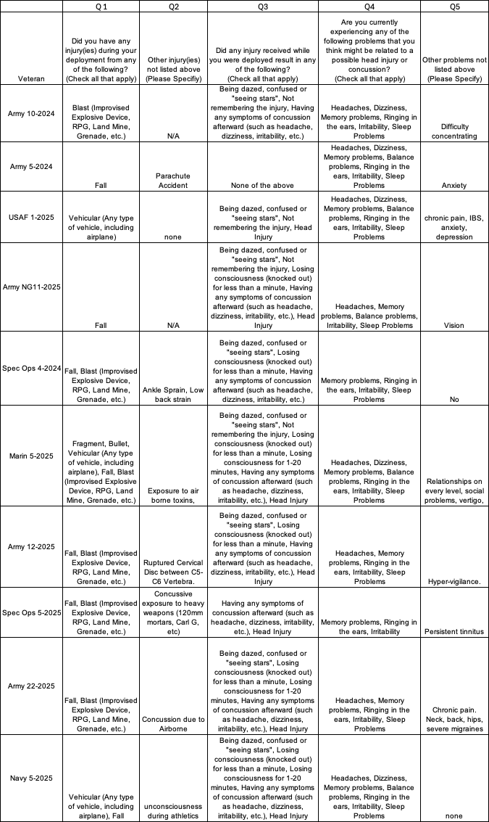
Drug Abuse Screening Test (DAST)
A bank of 28 question self-report scale that consists of items that parallel those of the Michigan Alcoholism Screening Test (MAST). The DAST has “exhibited valid psychometric properties” and has been found to be “a sensitive screening instrument for the abuse of drugs other than alcohol. Every Veteran is drug tested prior to beginning HBOT treatments.
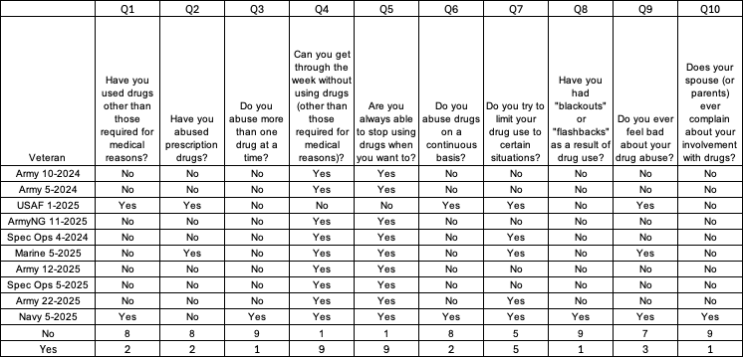

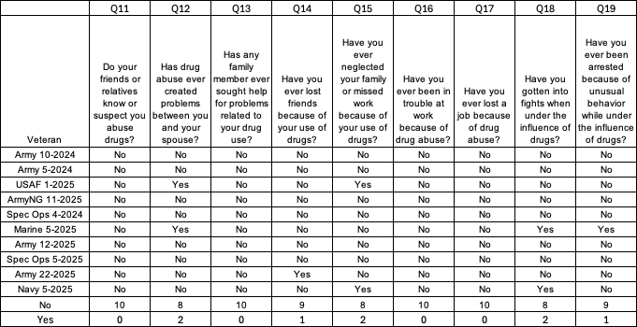

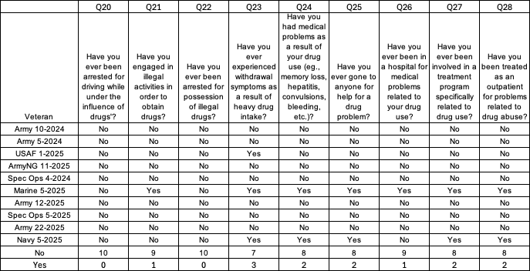
- There was no statistical data to reflect on any negative trends. There were 256 no answers and 56 yes answers.

Michigan Alcoholism Screening Test (MAST)
The MAST screening tool is a 26-question test that is used to help identify an alcohol dependency. Questions included in MAST are related to: risks associated with drinking patterns, neglect of responsibilities, loss of control, and other topics.

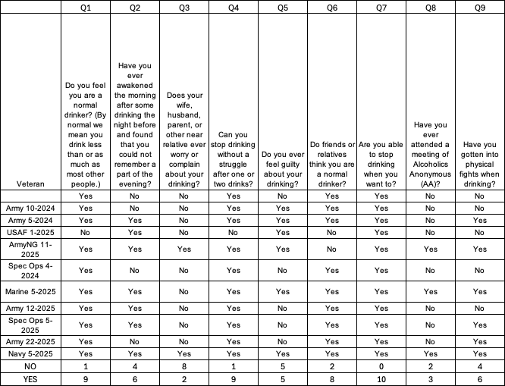
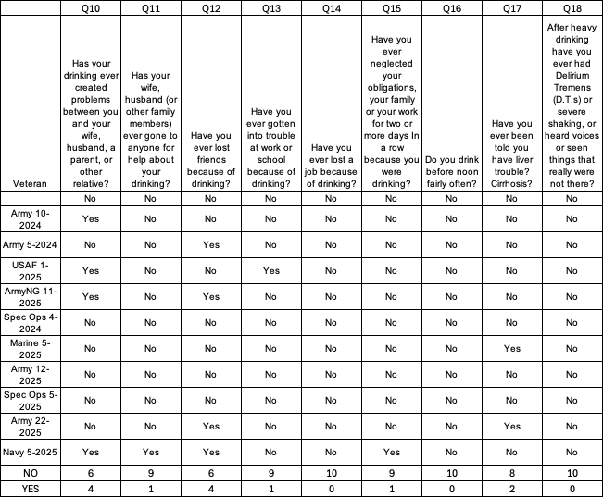

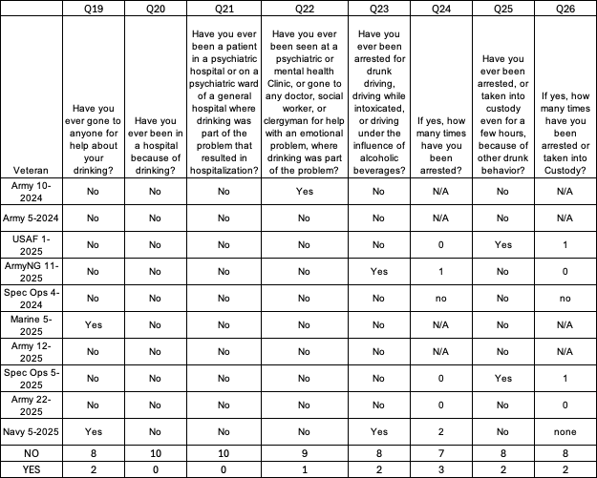
- There were 172 no answers and 83 yes answers.
- 50% felt guilty about drinking, 60% have engaged into physical fights when drinking, 40% believe drinking creates problems with relatives, 40% have lost friends due to drinking, 20% had a DUI and 30% have been arrested.
- The statistical data reflects alcohol is an issue and several are self-medicating in the past or present. Self-medication amongst TBI/PTSD to mask pain and cognitive related symptoms is common occurrence.
- Veterans sign a Treatment Agreement informing them if they show up for treatments under the influence of drugs or alcohol they will be terminated from the program as this is a medical safety issue.
Overall HBOT Treatment Testing Summary
- A total of six Veterans completed the treatment program and 10 TBI Veterans are currently in the HBOT treatment program for a total of 16 who have submitted applications and have completed or are currently in treatments. Two Veterans did not take the final ANAM tests as they were waiting on previous test results.
- A total of 11 have completed treatments since 2020, 6 since July 2024. A total of 7 of the 11 completing treatments are either back in school, back to work part-time or full time (64%).
- Average cost to test and treat TBI/PTSD Kentucky Veterans is $15, 020. 39 in 2025 cost.
National Veteran Testimonials

With our national partnership with TreatNOW.org, we have YouTube library of 100+ TBI/PTSD Veterans and family member testimonials which may be viewed https://www.youtube.com/@treatnowdotorg/videos.

Testimonial highlights include Dr. Joseph Maroon, MD, former Neurosurgeon of the NFL Pittsburgh Steelers, Army BG (Ret) Patt Maney, retired District Court Judge and now Florida State Representative, 2014 Former Marine Corp Commandant Conway and Navy Admiral Roughead, Chief of Naval Operations testifying before the US House on HBOT, several Navy SEALS, Army Vietnam Medal of Honor recipient Sammy Davis (the real Forest Gump) and his wife Dixie, and an Army Afghanistan Chaplain Veteran.

Kentucky Veteran Individual Written Testimonials

The heart of HBOT4KYVETS, Inc mission is reflected in the powerful stories of the Veterans we serve. These individuals, who have bravely served our country, often return home carrying the invisible wounds of war, including TBI/PTSD and other medical challenges. Through the Kentucky enacted KRS 217.930-942 in 2018 and the funded HBOT treatment program in 2024, Veterans have experiences life-changing relief and healing with Hyperbaric Oxygen Therapy (HBOT).
In this section, we present multiple testimonials from Veterans who have directly benefited from HBOT4KYVETS, Inc program. These stories highlight the profound impact of this innovative therapy, from restoring brain health and mental clarity to renewing hope and purpose. Each account demonstrates the critical importance of our continued efforts to expand access to HBOT for Kentucky Veterans.
These testimonials are not just a narrative of individual recovery. They are a testament to the effectiveness of HBOT as a medical adjunctive therapy to combat the Veteran mental health crisis, to include the suicide and opioid epidemics that have decimated our Veteran community across the country. As you read their words and stories, we hope you’ll see the undeniable value of sustaining and enhancing this program to reach more of our nation’s heroes, especially here in the Commonwealth. Names are de-identified for accounting cost submittals and HIPAA protection and secondary names assigned for tracking purposes, which are used herein below for their written testimonials. The written testimonials are as submitted to HBOT4KYVETS, Inc.
Army 2-2024

“After 9 dives, I am sleeping much more and feel really rested. A whole lot less fatigue, headaches have really decreased in frequency and intensity. After about two weeks of treatment my headaches from my TBI that I sustained on December 22, 2008, started to subside in frequency and intensity. My sleep also started to improve. I was able to fall asleep easier, sleep longer and wake up more refreshed. One of the main reasons I accepted this treatment even though it required a long commitment to the program (40 dives) is because I was suffering from memory loss. Although I have not regained the memories that I have lost I have found it easier to remember new things and recall words. I am currently headache free and feeling much better. On a side note, my depression is much improved. I was not treated for that, but I thought it worth mentioning.”

Army 1-2024

“Lot more energy, sleeping better, brain fog gone, no headaches since treatment started, after the first two weeks. Phone call at 0930, treatments are really going well. I am no longer tired after treatments and feel fully energized when I complete each treatment. No longer have any headaches, I am sleeping 6-7 hours per night, by lower back disc pain is also gone. I am really enjoying the treatments at Norton Clark, the staff and Bob Thacker are taking good care of me. I am not experiencing any other cognitive issues I had in the past.”

Army 10-2024

“Sleep slightly improved. Only experienced 1 headache this week (down from 3-4 prior to treatment).: 1 headache during the week which is still a decrease from usual. Some ear issues that only lasted about 1 hour. Sleep was good.”

Marine 1-2024

“Sir, today was dive 59 of my scheduled 60. I feel great! It is like an entirely different world has opened for me. Thank you from the most sacred part of me. As I think about what it was like living trapped in a mental imprisonment for 25 years I have a type of regret. Having the ability to engage in every moment and to have intention in my thought processes after have been gifted the opportunity to do HBOT brings so much joy. But, I think of all the time spent where I was unable to truly feel. I didn’t know any difference, but now I can live without constant migraines, no ringing in my ears, able to focus, can be intentional in my thoughts. HBOT was a key for me that unlocked doors and gateways in my mind where I have the ability to manifest intention with clarity.”

Marine 3-2024

“The changes I have noticed have been mostly little but profound things concerning memories and thinking. There will be random times that I will have flashback-style memories of various parts of my past from childhood through military service. Only these flashbacks are of memories I hadn't previously recalled, or I recall them in more accurate detail. The back story with that is that I have been experiencing a lot of frustration over the years concerning my memories and knowing that I couldn't trust them anymore.”

“Over the last decade and a half, I have not been able to trust my own memory or memories. I will use military service as a relatable example. I would have memories of an event in a country with a specific unit I was with at the time, only the catch is that the "characters" in the memory are sometimes the wrong people as in people who were not at the event, or even in the unit or country at the time. There are also entire events (not even traumatic) that were like they didn't happen. I've had conversations with people that I would have later sworn under oath that they hadn't occurred. While dealing with that and other issues I wasn't able to articulate what I was experiencing in any relatable or understandable form. There was also a lot of “background noise" in my thoughts making it difficult to concentrate and accomplish tasks.”

“Throughout those last 35 dives, I have also noticed a decrease in the "background noise" present when I am trying to focus. I haven't been losing my train of thought mid-sentence as often. I am also becoming less reliant on GPS to make sure I don't forget where I am going. There were a few days that I thought I noticed a decrease in light sensitivity but that doesn't seem as consistent. Some days are unbearable without sunglasses, but there have been a few where I would notice that I would have normally needed glasses but was okay without them. It hasn't seemed as consistent as slowly regaining some memories, and other scrambled memories falling into place. I also still get the occasional headaches. It is very promising to see the improvements in things I had believed that I was just doomed with for the rest of my life. One of my biggest fears was losing myself way too young because of how it would feel with common words would even escape me in mid-sentence.”

“In 2007, while deployed in Iraq, I was exposed to multiple direct IED blasts and several close- proximity rocket impacts—some powerful enough to lift me off the ground and throw me a few feet. All of this occurred within a four-month period. One of the blasts also caused a torn labrum in my left shoulder. At the time, I didn’t seek medical attention, nor did I fully understand the impact these events had on me. I struggled to put into words what had changed. At times, I would even forget words mid-sentence.”

“For years, I simply coped with it. Nearly a decade later, after growing frustrated with my symptoms, I sought answers. In 2015, I went through the TBI clinic at Ft. Knox, and since then, I’ve undergone years of therapy for PTSD, ADHD, OCD, anxiety, and adjustment disorder. Over the past few months, I’ve experienced significant improvements through hyperbaric oxygen therapy. My mental clarity has greatly improved—I can focus better and experience far less fatigue. Before, there was a constant “background noise” in my mind, making it difficult to concentrate, which often led to frustration and anxiety. Hyperbaric therapy has drastically
reduced that noise, providing a clarity that surpasses any ADHD medication I’ve taken in the past. The psychological issues are much more manageable and less life impacting, making the previous therapy much more effective now than it had seemed to be in the past.”

“I do still get headaches, but they are less frequent, less severe, and shorter in duration. When they do occur, low-dose OTC medication is enough to manage them. I’ve also noticed a slight decrease in my light sensitivity—particularly with artificial lighting and on cloudy days, though direct midday sunlight remains a challenge. Physically, I recover faster from workouts, with reduced muscle soreness and quicker healing. This has helped alleviate the persistent aches and pains in my left shoulder. These improvements have had a profound impact on my daily life, allowing me to be more active, engaged, and present with my kids and those around me.”

Spec Ops 3-2024

“Per our phone conversation yesterday, here is the “top 3” list of TBI symptoms I’m hoping to have some relief from following hyperbaric treatment.

- Short- and long-term memory loss. I have noticed a significant decline in memory loss and its has been incredibly frustrating. Whether it’s childhood memories from long ago or remembering someone’s name who literally introduced themselves 1 minute ago, my lack of memory drives me crazy. Hopefully this gets a little better.
- Social withdrawal/social anxiety. I hate large groups of people, especially people I don’t know. I have read this is a common symptom among NFL football players with concussions as well. I’ve never been a social butterfly, but it’s never been this bad.
- Ringing in the ears. It happens randomly and isn’t debilitating but very annoying. I’ll be hunting in the quiet woods and all of a sudden, unsolicited, an ear will start ringing. Hopefully this gets minimized.”

USAF 1-2025

“I have seemed to notice that I have an overall improvement in generalized body pain, which I document in a journal. I still get flare-ups and still have mild existing pain, but the intensity and duration of the intensity seem to be reduced. I am still having pain issues in my neck and right shoulder, but like my body, the intensity and duration seem to be improving. My sleep quality has improved quite a bit for the nights that I am able to sleep. I am still having nights where I am only able to get 1-3 hours of sleep, but those nights seem to be less frequent. The nights that I have issues are due to pain flare-ups. I still wake with intense pain in my neck and right shoulder. I am still having issues with being able to function on the sleepless nights due to mental, emotional and physical exhaustion. Some of these days are very difficult to get through. I tend to not only struggle with being able to function in every sense but also have major issues with depression on those days. I don't have the mental clarity or strength to focus or redirect my attention.”

“I am still staying active, doing my regular yoga routine; stay busy around my home, in the process of a light renovation to prepare to sell. I have been taking a supplement called Stemregen as well that is supposed to aid in the activation of the body's stem cell repair process. I try to be very cautious of what I put in my body as far as junk food, etc. go, although I did order Domino's last night and got the cookie brownie desert with the pizza, most days I am disciplined in keeping junk food at bay. So, I definitely believe that something is working! Compared to where I was at a month ago, I feel vastly different in a positive way.”

Wife of Marine 5-2025

“I told you incorrectly the other day when I said John had only had 15 or so treatments. He’s in his 23rd dive as I type this. His tinnitus symptoms have decreased by 70%. His anxiety and OCD (particularly repetitive intrusive thoughts) have decreased dramatically. Overall, he has more clarity of thought. I’ve also observed that his
short-term memory is improving. I’ll give another update on this next week.”
2024-2025 KDVA MONTHLY AND ANNUAL METRICS AND MEASUREMENTS
Financials
HBOT4KYVETS, Inc contracts HBOT services with a group of four Kentucky hospitals operating Wound Care Center Hyperbaric Oxygen Therapy (HBOT) treatment centers. The hospitals are staffed with trained, licensed, and certified Medical Doctors, and medical HBOT technicians. HBOT treatment costs include actual HBOT treatment services, medical doctor services, and medical support services. HBOT testing costs include FDA approved pre and post HBOT Right Eye, FDA cleared, and DoD approved pre and post HBOT Automated Neuropsychological Assessment Metrics (ANAM) cognitive testing, a battery of four additional computer-based tests, and pre HBOT treatment Drug and Alcohol Testing.

HBOT4KYVETS, Inc negotiated and executed formal business contracts with each hospital, testing services, and Drug and Alcohol testing service providers which define medical expenses. Every effort was made to negotiate and establish Medicare pricing rates for medical and testing services provided or lower.

HBOT4KYVETS, Inc total expenses from July 1, 2024 (effective start date of KDVA MOU) to December 31, 2024, were $140,739.62. Expenses from January 1, 2025, to May 30, 2025, were $99,586.64. June expenses are not included in the report based on this annual report due prior to the end of June and normal expense reporting is not required until the 5th of following each month. Total expenses for the HBOT4KYVETS, Inc budget period (July 1, 2024, to June 30, 2025) was $240, 326.26 with June 2025 expenses not included.

2024 Reporting 2025 Reporting 2024-2025 Reporting
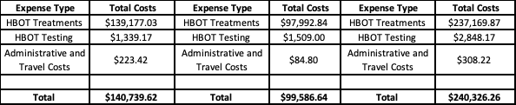

Total Kentucky budget allocated funding was $750,000 per budget year or total of $1.5 million over the two-year budget cycle. Total state funding remaining is $509,673.74 ($750,000-$240,326.26). The original budgeting projection was 50 TBI Veterans to be treated per year or approximately 4 per month which would have equated to the $750,000. We have treated an average of 1.3 Veterans per month. There are multi-reasons driving the shortfall of TBI Veterans in the treatment program. They include but not limited to the Louisville and Lexington VA facilities refusal to support the alternative treatment, lack of statewide news media coverage and advertising, limited availability of facilities in demographic areas we would like to have coverage, and transparency of our treatment program. Veterans face two dilemmas; accepting another treatment program when all others have failed, and PTSD diagnosed only Veterans not qualifying for treatments under KRS 217.934 (1).

A total of six Veterans who completed treatments during the financial reporting period and additional 10-Veterans currently in the treatment program. Averaging total expenses for the 16 total Veterans in the treatment program equals $15,020.39 in testing and treatment cost per Veteran ($240,326.26/16).
The number of HBOT treatments per Veteran varied based on actual number of chronic TBIs, severity of TBIs, and length of time since the TBI brain wounding occurred. A Veteran with 10 TBIs may require 100 HBOT hours of treatment versus a Veteran with one TBI who may only require 20-40 HBOT hours. The average number of HBOT dives to eliminate cognitive related symptoms from TBIs per Veteran is averaging 60-80 hourly dive regiment or 3-4 months of treatments for each Veteran based on actual treatments conducted.
The Economic Impact of TBI/PTSD Veterans in Kentucky Report was delivered to the legislative leadership on or about May 15, 2023 (copies available upon request)
Traumatic Brain Injuries, the “invisible wounds” and the “signature injuries” to US service members is over 877,450, in addition to the tens of thousands of visibly wounded combatants. It is fair to say that costs continue to escalate partly because of bad science brought about by medicine’s unwillingness to accept worldwide science and evidence of new, non-standard treatments that are healing brain wounds
Approximately 19,394 Kentucky Veterans were Medicaid covered in 2015, and of this number, 54 percent were disabled, 11 percent had mental illness and 12 percent substance use disorder for a total of 76 percent or 14,739. Our estimate of 12,050 TBI Kentucky Veterans is under stated in this analysis. Consequently, our projected annual TBI/PTSD Veteran societal economic impact financial analysis is also under reported.
In 2019, approximately 64.7 million citizens were enrolled in Medicaid, with persons with disabilities under the age of 64 in 2016 average Medicaid cost was $19,753 per expenditure. Overall, expenditures on Medicaid for FY2017, including federal funds, consumed 28.9 percent of state budgets. We estimate a percentage of TBI Veterans qualify for Medicaid financial assistance. Our research did not conduct a financial assessment of TBI qualified Medicaid Veterans who qualified for compensation expenses across each state and are not included in the analysis which we conducted.

The current annual economic societal cost (Table 1 in the Report) for Kentucky TBI/PTSD Veterans who live with an untreated, undiagnosed, or misdiagnosed TBI is estimated to be $484,249,150. For the estimated 12,050 TBI/PTSD Veterans in our Commonwealth, an annual $40,186 cost per TBI/PTSD Veteran (Table 2 in the Report) or $19.3 billion over 40-year lifespan (Table 3 in the Report). There are an estimated 877,450 U.S. brain-wounded post 9/11 service members across the US. “The VA estimates that the 10-year cost of caring for post-9/11 veterans with Traumatic Brain Injury (TBI) alone will be $2.4 billion from 2020 to 2029.”
Average cost to test and treat TBI/PTSD Kentucky Veterans is $15,020 in 2025 cost. The untreated, unemployed or unemployable Veterans estimated cost is $40,186 per year, that is an average cost savings of $25, 166 if Veterans are returned to the workforce. This does not include savings in hospitalizations, medical interventions, pharmacology reductions, etc.
2024-2025 KDVA Monthly and Annual Advocacy and Outreach Reporting Metrics and Measurements
The Advocacy and Outreach Metrics and Measurements are designed to track and enhance visibility and understanding of the Hyperbaric Oxygen Therapy treatment program across multi-facet organizations across the state. Actual HBOT treatments were not funded until July 1, 2024, but communications efforts began in June 2024. June 2025 was not included in the reporting period as this report is deliverable prior to the end of June 2025 and reporting of elements are usually not completed until the 5th of the following month.
There is a total of 7 elements with 12 monthly reporting periods for Advocacy and Outreach for a total of 84 reporting periods. We completed 70 reporting periods or 83.3% whereas communications were initiated to the varying organizations in varying periods. The top three communication entities were the KY Legislature 23 or 33%, News Media 14 or 20% and VHA communications 13 or 18.5% of elements. Metrics and measurements are by design to be dynamic and fluid to capture and report value added elements. Upon review of elements if they are not producing desired outcomes, assessments should be conducted to change elements.
The three top elements accounted for 71.5% of communications. The VHA communications did not provide a single return from either the Lexington or Louisville VA facilities and there were no values extracted from our proactive communications either directly or during monthly VA Town Hall scheduled meetings. Our efforts with the VHA communications could be more limited in 2025/2026 as a result.
We will focus on those entities who have embraced our state approved and funded program and work with their partners to leverage their networks and ability to reach Veteran centric organizations outside of the VA network. We will work to expand the number of treatment facilities across Kentucky as well.
2024-2025 KDVA Monthly and Annual Education Reporting Metrics and Measurements
The Education Metrics and Measurements are designed to track and enhance visibility and understanding of the Hyperbaric Oxygen Therapy treatment program across multi-facet organizations across the state by education and sharing of medical material. Actual HBOT treatments were not funded until July 1, 2024, but communications efforts began in June 2024. June 2025 was not included in the reporting period as this report is deliverable prior to the end of June 2025 and reporting of elements are usually not completed until the 5th of the following month.
There is a total of 7 elements with 12 monthly reporting periods for Advocacy and Outreach for a total of 84 reporting periods. We completed 51 reporting periods or 60.7% whereas educational material was initiated to or shared with the varying organizations are varying periods. The top three education entities were the KY Specialty Courts Communications 17 or 20.2%, Military Connected Communications or 17.8% and HBOT4KYVETS Material Distribution 11 or 13% of elements. The three top elements accounted for 51 % of education material. For both Advocacy and Outreach and Educating Metrics, a total of 121 measurements were completed of the total 168 or 72% of total measurements.
Public Relations and News Media
We have proactively approached news media outlets in Louisville and Lexington, the two largest Veteran demographic areas in the state with an estimated 60,000 Veterans in Louisville and 20,000 in the Lexington areas. This is approximately 30% of the total state Veteran population. We are working to bring awareness of the state approved and funded program for invisible wounded TBI/PTSD Veterans concerning the safety and efficacy of the alternative treatment program. The two news media events have proven to be effective in recruitment applicants, and we will continue to pursue this effort.
On September 24, 2024, WDRB Louisville broadcast a 4-minute video filmed at the Clark Regional Medical Center in Winchester, a service treatment partner in our program. It highlights how HBOT4KYVETS, Inc began its treatment program and what it is offering to TBI/PTSD Veterans. The full video may be viewed below.
Free treatment for veterans diagnosed with TBI accompanied with TBI/PTSD now available after $1.5 million in funding.
https://www.wdrb.com/in-depth/free-treatment-for-veterans-with-ptsd-now-available-after-1-5-million-in-kentucky-funding/article_e658164c-781d-11ef-ab5d-f7a8f037df60.html
On April 15, 2025, Fox 56 in Lexington broadcast a 4-minute video filmed at the Norton Clark Hospital in Jeffersonville, IN, a service treatment partner in our program. One of the TBI Veterans completing treatments was interviewed on the safety and efficacy of the treatment program. The full video may be viewed here.
https://fox56news.com/news/kentucky/healing-hidden-wounds-kentucky-veterans-find-hope-in-hyperbaric-oxygen-therapy/
We developed a 10-minute video that provides a generalized summary of a HBOT treatment program and how it is administered. The video may be viewed here.
https://www.youtube.com/watch?v=EwFTvnwKPKg&t=373s

Jennie Stuart Medical Center in Hopkinsville, KY is our fourth treatment facility partner released this WKDZ 106.5 FM radio broadcast on February 21, 2025, and you may listen to the conversation here.
https://www.wkdzradio.com/2025/02/21/jennie-stuart-health-offering-hyperbaric-therapy-to-vets/news-edge/
State and National HBOT Legislation
We have helped to enacted HBOT legislation in 12 states since 2014 when Oklahoma enacted the first HBOT bill for TBI/PTSD Veteran. A summary of the state by state enactments may be viewed here. https://treatnow.org/knowledgebase/the-national-treatnow-summary-of-state-by-state-hyperbaric-oxygen-therapy-hbot-legislative-and-resolution-effort-10-23-2023/. North Dakota and Tennessee were added in 2025 and will be added to the state HBOT summary but is included here below on the 2025 summary of legislative session efforts.
What do we need? In the 12 states who have HBOT enacted, state House and Senate legislatures to speak with the US Congressional members and request funding through the VA Research budget to treat TBI/PTSD Veterans and reimburse state budgets providing lifesaving treatments in accordance with the U.S. Veterans’ Bureau War Risk Insurance Act of 1924.
2025 HBOT State Legislative Session Efforts Underway

The states listed below are in addition to the 12 states (OK, IN, AZ, TX, KY, FL NC, WY, MD, VA, ND, TN) which have enacted HBOT legislation since 2014. Seven of the enacted HBOT states are funding over $33 million in HBOT treatments. The widespread efforts across the entire US to enact HBOT legislation and treat our invisible wounded Veterans with safe and effective HBOT that the Israeli Defense Force has approved for the past decade. Status on drafting, discussion and or HBOT bills being submitted for review. Current 2025 state legislative sessions HBOT efforts to include the following:

- Indiana-BG Jim Bauerle, bgjimbauerle@gmail.com
HB 1120 extends HBOT Pilot Program for TBIU/PTSD Veterans beyond the June 30, 2025, end date.
SB0206 Indiana Dept of VA to administer funding of treatment program for TBI/PTSD Veterans
Indiana was the first state to appropriate $1M in HBOT funding for TBI/PTSD Veterans. The above bills provide additional funding to extend the program into an ongoing program with funding through “The Military Family Relief Fund.” The fund receives revenue from Veterans who purchase military specialty license plates.
- Iowa-Lori Stiles, loristiles.osv@gmail.com. 515-321-6615 cell
HF 326 is now HF 518 drafted, passed Sub-committee and Committee. It has passed out of VA Committee on Feb. 18th, was stalled in House Appropriations Committee with $5M funding. The bill will be re-introduced in January 2026 legislative session.
- Kentucky-Eric Koleda, ewk7405@aol.com, 502-938-1300 cell
SB 135 adding PTSD language to KRS 217.930-942 which was enacted in 2018. The bill was not introduced into Committee and did not receive any review. We will work on the bill re-introduction in 2026. HB 1 funded HBOT treatments for $1.5 million in 2024 over 2-year period through June 30, 2026
- Michigan-Kevin Hensley-hensleyk75@yahoo.com, 478-334-0051 cell
HBOT bill HB 5146 was introduced in the House and has been modified and not migrated out of Veteran Affairs Committee. The bill is being re-worked and will be re-introduced under a different bill number in the summer 2025. Michigan has a full year legislative session.
- Missouri-Dale Lutzen dlutzen@gmail.com, 402-312-7895 cell
HB 262 has passed through the rules committee, the House and Senate and currently awaits the Governor signature; HB 262 is listed with other Veterans bills. $5 million has been requested in the budget for HB 262 and status is still pending. Senate vote 31 Yea-2 Nay, House Vote 156 Yea-Nay 1
- North Dakota- HCR 3011 was enacted and signed by Governor in 2025 which urges US Congress to provide Veterans medical coverage for HBOT treatments. No roll call vote counts available.
- New Jersey-AJR 178 was introduced with 10 sponsors which urges US Dept VA to study the use of HBOT treatment for TBI/PTSD Veterans. Status pending. Currently in the Military and Veterans’ Affairs Committee.
- New York-Joel Goldstein-jgoldstein@thefartfoundation.org, 845-797-7869 cell
Bills S.01715/. A01869 drafted, establishes 5-year pilot study to provide HBOT to TBI/PTSD Veterans, working funding efforts with Veteran Affairs Committee Chairman, bill working through House and Senate Committees. NY has full year legislative session.
- Oregon-Connie Hunter, Hunter-connie.hunter@oregonlegislature.gov, 602-541-5903 cell
HB 3460 drafted, working on language changes as it migrates through Joint Committee on Ways and Means.
- Tennessee-HJR0001-Signed by the Governor and enacted on May 5, 2025. Resolution to US Congress to enact legislation to expand and improve efforts to treat TBI and PTSD Veterans.
- Texas-Dr. Joseph McCoy, McCoy-jmccoy@vpsrgv.com, 956-882-0385 cell, Adding funding to HB 271 enacted in 2017. HB 217 established the Veterans’ Recovery Pilot Program to provide HBOT.

Preventing Suicides and Restoring Families
The National DoD/VA military suicide rates have remained largely unaffected by the US suicide prevention strategy over the course of the past 23 years. Specifically, in the past six-year there has been 15 published “suicide prevention” strategies, directions or goals. Included in these are document provided by US Congress, the White House, CDC, NIH, DoD and several military services. The CDC, in the 2024 National Strategy for Suicide Prevention and the Veterans Administration in the 2023 National Suicide Prevention Annual Report, and the published 2021 book, The National Brain-Wounded Veteran Brain Drain have confirmed this results.
- There are no FDA approved drugs for TBI, yet hundreds are prescribed off-label without any measure on its negative impact to human health.
- Over 847 million opioid pills delivered to TBI/PTSD Veterans in the VA (DEA.gov) from 2006 to 2014 as reported in 2021 published The National Brain Wounded Veteran Brain Drain 2021 published book.
- Veterans suffering from TBI/PTSD symptoms over prescribed with video testimonials on their treatments and outcomes on the YouTube video testimonial section.
- Over 1.1 million battlefield and combat related deaths since the Civil War with the Iraq and Afghanistan conflicts reporting the lowest combat deaths since 1861 of 7,057 but over 260,000 suicides and opioid deaths in the last 22 years.
- Since 2003, we are experiencing two parallel Veteran epidemics in suicides and opioid use deaths directly related to the invisible TBI/PTSD brain injuries.
- Irritable Heart, Shell Shock, Combat Fatigue, PTSD, Gulf War Syndrome, 155-years of undiagnosed and mis-diagnosed TBIs but thinking Veterans have mental health issues versus the invisible physical brain injuries (concussions/TBI/PTSD/PPCS. There is NO FDA approved drugs for TBI.
- Talk therapies and off-label prescription medications for TBI/PTSD decimates the Veteran community with over 153,000+ suicides
- 23-year suicide prevention strategy which has not changed or pivoted to new medical proven and demonstrated safe and effective alternative treatment like Hyperbaric Oxygen Therapy (HBOT)
- Over 98 percent of the current pharmacologic treatment for TBI and PTSD are off label. Yet, treating TBI with off-label drugs, processes, devices, and protocols not approved by the FDA for TBI/PTSD is a continuing formula for failure to prevent, much less reverse, the TBI Veteran suicide and opioid epidemic. Failures of a growing number of psychological interventions have also proved ineffective in reversing the suicide epidemic. Costs and suicides continue to escalate
- The chart below reflects over $3.3 billion expended on suicide prevention by VA with no significant improvement for the invisible wounded TBI Veterans. A total of $5.3 billion expended by DoD, VA, CDC, HHS, NIH.
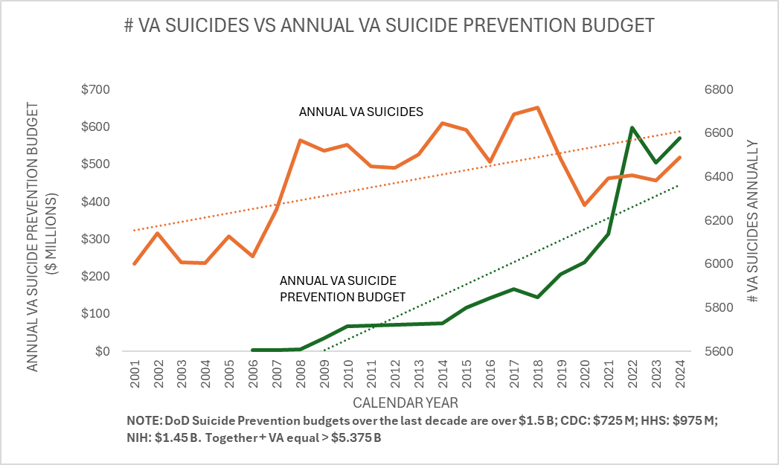
The chart was compiled from data extracted from VA Budget Submittals to the US Congress and from VA.gov
Amplifying Results and Evidence
- North Carolina has published similar HBOT reports and they may be viewed here.
- The mounting and compelling worldwide medical and scientific evidence coupled with demonstrated TBI/PTSD Veterans receiving HBOT treatments and healing is profound.
- Over 31,000 U.S. patient successes, including 12,500+ TBI/PTSD treated Veterans, over 500 Navy SEALS through the TreatNOW Coalition of 160+ independent HBOT treatment clinics across the U.S.
- HBOT treatment approved and deployed by Israeli Defense Force (IDF) for over a decade for TBI/PTSD Veterans and citizens through The Sagol Center for Hyperbaric Medicine and Research at Shamir Medical Center. This is formerly Assaf Harofeh Medical Center, the largest HBOT center worldwide treating over 200 patients per day. A leader in the pioneering research on novel indications of hyperbaric medicine for cognitive and physical rehabilitation and performance.
- The 1990 Textbook of Military Medicine has recommended with evidence of Arterial Air Embolism HBOT for Blast Exposure TBIs for 35-years
- 12 states enacted HBOT legislation for TBI/PTSD Veterans, 7 funding over $32 million in treatments since 2014
- HBOT is FDA approved for biologically repairing and regenerated human tissue
- A total of 27 clinical trials and studies to include a total of 900+ successful patient medical outcomes since 2007 is depicted in the chart below.
18-Years of Proven Safe and Effective HBOT Treatments for TBI/PTSD
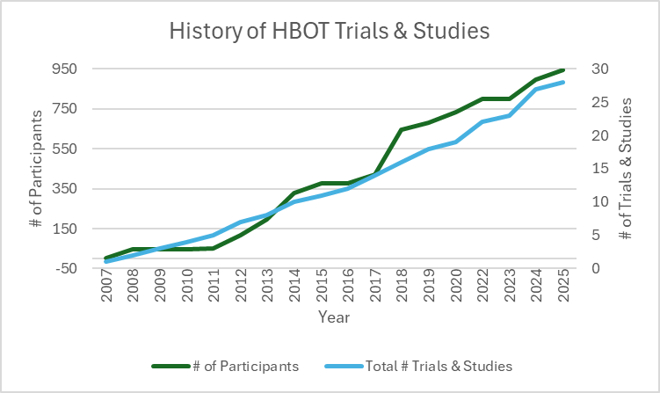
- HBOT is already FDA approved for five brain injuries: Carbon Monoxide poisoning, arterial gas embolism, cerebral decompression sickness, intracranial abscess, and non-healing wounds
- HBOT is approved and on-label for 14 FDA indications, breathing 100% medical grade FDA approved drug called “oxygen”, under pressure, in FDA approved HBOT chambers with
- The National Brain Injury, Rescue, and Rehabilitation (NBIRR) Study post HBOT results include Nearly a 15-point IQ increase (difference between H.S. drop out and college graduate), 51% reduction in depression with virtual elimination of Suicide Ideation, 30% improvement in PTSD symptoms 87% headache reduction, 64% reduction in prescriptions, 96% functional emotional improvement and significant reduction in anger issues.
- Palliating TBI/PTSD Symptoms with off-label drugs leads has contributed to over 153,000 Veteran Suicides and another 109,000+ opioid deaths
- VA introduced an opioid epidemic from 2006 to 2014 with over 847 million opioid pills (DEA.gov) distributed by 4Q2012 to over 679,000 Opioid Use Disorder (OUD) Veterans
Broad Support Among Veterans for Alternative Treatments
Mission Roll Call is a national, nonpartisan 501(C)(3) located at https://missionrollcall.org/veteran-voices/polls/. They partner with our network of Veterans, their families, supporters, and Veteran service organizations in our coalition to advocate for positive change in the lives of all veterans. As seen in the poll results below, in general the respondents to our survey support the inclusion of novel treatments for ailments. Mission Roll Call is working with serval partners to introduce initiatives to help Veterans where the research and results support it. Highlight just one issue below, the studies on Hyperbaric Oxygen Therapy are promising and merit further support from Congress and the VA. Nearly 2,000 responses from all 50 states, and 95% of respondents are either a Veteran or family member of a Veteran.
Do you think the VA should allow Veterans with service-connected mental health challenges to access the mental health provider of their choice, even if not in the VA system?
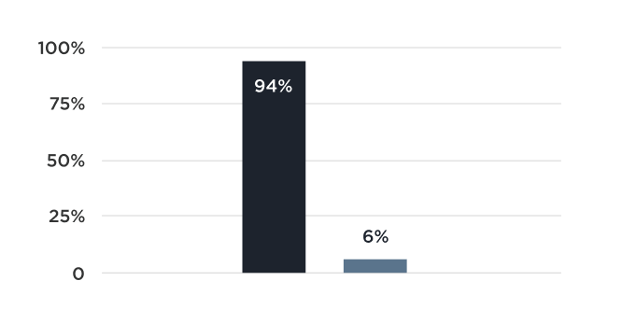
Yes-94% No-6%

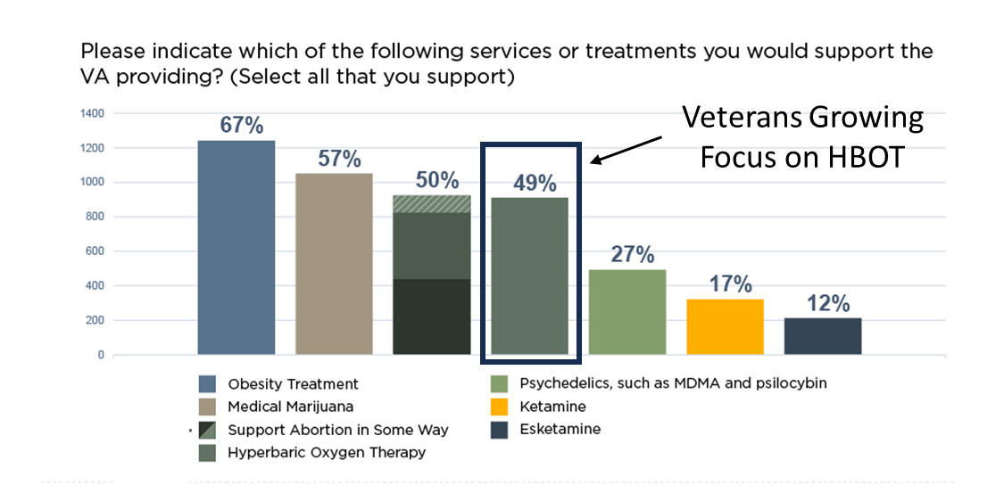

A total of 49 percent of Veterans support having Hyperbaric Oxygen Therapy as a treatment option within the VA.
Community Care is the lightning rod issue in Washington, falling along partisan lines. On the one hand, many Veterans struggle to access VA care for various reasons, from lack of specialist in their local area, to excessive travel times, to lengthy wait times. Community care efforts are intended to empower the Veteran to be their own best advocate in what care makes the most sense for them.
On the other hand, a formidable group of lawmakers and some VSOs are concerned that community care is akin to privatizing the VA, and risks removing the VA’s oversight role in delivering the best care possible for Veterans.
Our interactions with Veterans through our polling and discussions informs our position that there is no one size fits all solution with the community care debate. Many veterans are perfectly happy with the care and services the VA provides; many others are extremely dissatisfied with the VA, often for reasons connected to lack of timeliness, options, or flexibility. Less than 50% of Veterans are registered in the VHA.
The published medical evidence and financial benefits of HBOT for Veterans for both on and off label indications is compelling. FDA, CMS and Tricare approved HBOT indications are not routinely prescribed and or offered to Veterans as shared in the 2022 VA data report and the TreatNOW report to the US Congress in October 2022. There are by recent accounting over 66,000 Veteran Service Organizations (VSOs) around the country providing some level of service and support for Veterans and their families. If the service needs of our men and woman who served are being met, why have 66,000 VSOs surfaced across the country? Through the TreatNOW organization we have a national network or clinics, medical doctors, nurses, HBOT technicians and advocates working daily to reduce the Veteran suicide epidemic that has engulfed our invisible wounded Veterans. They are producing results with only one reported suicide in treating over 12,500 TBI/PTSD service members since 2008.
The current VA 172 hospitals and 1,100+ clinics across the country do not operate a single HBOT chamber for providing HBOT services to Veterans as shared by Dr. Steven Lieberman, Under Secretary of Health in the 2022 data report. There are no plans to integrate HBOT services into the VA into the foreseeable future. Consequently, these services are required to be provided through the Community Care Network (CCN) partnered with the VA. The average age of diabetic Veterans in the VA system from 2001 to 2022 was 66.2 years, making them all eligible for Medicare HBOT coverage and a zero cost to the VA. The VA data report in 2022 indicated only 6% of Veterans were provided or informed about the FDA, CMS or Tricare approved HBOT indications (see Appendix C) in the CCN from 2001 to 2022.
According to the 2024 re-distributed report, “The Veteran Diabetic Foot Ulcer (DFU) Epidemic: A U.S. Department of Veterans Health Administration (VHA) Hyperbaric Oxygen Therapy (HBOT) Services Review”, 796,340 Veterans have died from 2001 to 2022 diagnosed with Diabetic Foot Ulcers (DFU) that resulted in Lower Limb Amputations (LLA). The report reflects 64-71% of LLA Veterans die within three years post LLA surgeries. HBOT is an approved FDA, CMS, and Tricare approved indication for DFUs since 2002 and worldwide data reflects 74% of DFUs are healed if HBOT treated timely, thus avoiding LLAs and death.
There is a need for the U.S. House and Senate Veteran Affairs Committee Chairs to begin investigating why HBOT services for on and off label indications is not being routinely offered or provided to Veterans in need of approved and alternative treatments. Our service men and woman deserve the best care we can provide as a nation, and we are failing our invisible TBI wounded and DFU Veterans.

APPENDIX A
HBOT4KYVETS, Inc Board of Directors

Eric Koleda

President, Director, Co-Founder, Veteran, Author, Advocate
In 1973 Eric Koleda enlisted in the USAF and served until 1977 on C-130’s and was honorable discharged as Vietnam Era Veteran. He received his Airframe and Powerplant FAA license from Teterboro School of Aeronautics, NJ in 1979 and began his airline career. Eric re-entered the USAF Reserves from 1980-1986 flying the C-141B aircraft and received his FAA Flight Engineer license. Eric worked within the airline industry for 35 years with four different air carriers, the last air carrier being UPS Airline as a startup management team member in 1988. He held varying management positions and levels of responsibilities in Quality Assurance and Quality Control, Line Operations, Finance, Procurement, Domestic and International Major Maintenance, and Airline Safety, retiring in 2013 after 26 years. Founder and President of Advance Aviation, LLC, an aviation consulting business for two years. Director and Co-founder of HBOT4KYVETS since 2018. Inc. Currently works as National Director, TreatNOW Coalition State Legislative Efforts. Published and co-authored The National Brain-Wounded Veteran Brain Drain with Dr. Robert Beckman in 2021. Holds BS and MBA degrees from Embry-Riddle Aeronautical University. Currently serves has President and Co-Founder of HBOT4KYVETS, Inc. managing the daily operations and funding efforts.

Eunice Van Winkle Ray

Director, Co-Founder, Publisher
In 1976, Eunice Ray began her work in publishing at a startup city magazine in Louisville, Kentucky titled Louisville Today Magazine. In 1981, as a young mother, she ran for the Kentucky General Assembly. She was subsequently appointed, by then County-Judge Executive, Mitch McConnell, to the Jefferson County Housing Authority. In April of 1988, she served on the Finance Committee in Kentucky for Bush’s Victory 88, in support of the election of George H. W. Bush for president. In 1991, Eunice was appointed by Secretary of Defense Dick Cheney to the Defense Advisory Committee on Women in the Service (DACOWTS), a 3-year, 3-Star Pentagon appointment to address the role of women in the Armed Forces post Desert Shield, Desert Storm. In 1996, Eunice co-founded RSVP America, a national grassroots campaign to Restore Social Virtue and Purity to America. Eunice founded First Principles Press, Inc., a not-for-profit educational organization that publishes historical and scholarly works. Today she serves as the president of First Principles. In 2018, she initiated and secured legislation to provide hyperbaric oxygen for Kentucky veterans with traumatic brain injury and was appointed by the governor to the state Council on Alzheimer’s, Dementia and Autism. Eunice is currently working to establish the Colonel Ronald D. Ray Library of American History.

Dr. Linda Jeffrey, Ed. D
Director
April 2000 to the present. Director of Research, First Principles Press, Inc. First Principles is a nonprofit ministry whose goal is to restore God’s Law to American public policy. My responsibilities include historical and legal research, writing, and preparing educational materials for briefings to military and legislative American leadership. I have prepared research monographs and white papers for publication in house, and for other Christian family advocacy groups. Projects have addressed Christian prayer and Exemplary Conduct in the U.S. military, development of materials for churches to teach our Christian Foundations in American History and writing an online version of The Bible in History and Literature, a project we developed for the National Council on Bible Curriculum in Public Schools. I am a certified teacher and have taught in grades 7-12.
Dr. Jeffery holds a B.S., Biology, George Peabody College for Teachers, 1975, Nashville, Tennessee, M.S., Natural Science, George Peabody College for Teachers, 1976, through a grant from the National Science Foundation Leadership Development Program, B.S., Physician Assistant Program, Trevecca Nazarene College, Nashville, Tennessee, 1978. Doctor of Education, Curriculum and Instruction, Department of Occupational Training and Development, University of Louisville, May 2000. Dissertation.

Pat Fox

Director, Veteran, Advocate
Pat joined the U.S. Army in November of 1980 as an enlistee and after 5-years of service was honorably discharged as a E-5 Sergeant. While completing and earning his degree in Business, Pat was in the Army Reserves and ROTC Program. He was commissioned as a Second Lieutenant in 1989 and was assigned into the Aviation Division as a UH-1 helicopter pilot in 1991 in the Army Reserves. After US Army flight school, Pat started his civilian career in Sales and Sales Management while still in the Reserves. Pat became involved in Veteran Non-Profits in 2019 as Executive Director with Active Heroes and now serves on the HBOT4KYVETS, Inc. Board

APPENDIX B
KRS 217.930 to 217.942
As used in KRS 217.930 to 217.942:
- (1) "Eligible patient" means a veteran who meets the requirements of KRS 217.934;
- (2) "Health care provider" means a licensed physician, a licensed advanced practice registered nurse, or a licensed physician assistant;
- (3) "Health facility" has the same meaning as in KRS 216B.015;
- (4) "Hyperbaric oxygen therapy" or "HBOT" means inhalation of one hundred percent (100%) oxygen in a total body chamber, where atmospheric pressure is increased and controlled, applicable to the prevention, treatment, or cure of a disease or condition of human beings;
- (5) "Traumatic brain injury" has the same meaning as in KRS 211.470;
- (6) "Veteran" has the same meaning as in KRS 40.010; and
- (7) "Written informed consent" means a written document that meets the requirements of KRS 217.936.
Effective: July 14, 2018
History: Created 2018 Ky. Acts ch. 14, sec. 1, effective July 14, 2018.
Legislative Research Commission Note (7/14/2018). 2018 Ky. Acts ch. 14, sec. 8, provides that 2018 Ky. Acts ch. 14 may be known as the "Colonel Ron Ray Veterans Traumatic Brain Injury Treatment Act." This statute was created in Section 1 of that Act.
217.932 Health care provider or health facility to provide hyperbaric oxygen therapy to eligible patients upon request.
- (1) A health care provider or health facility shall make hyperbaric oxygen therapy available to an eligible patient who has requested it pursuant to KRS 217.930 to 217.942.
- (2) The health care provider or health facility may:
  - (a) Provide hyperbaric oxygen therapy without receiving compensation; or
  - (b) Require an eligible patient to pay the costs of or the costs associated with hyperbaric oxygen therapy.
Effective: July 14, 2018
History: Created 2018 Ky. Acts ch. 14, sec. 2, effective July 14, 2018.
Legislative Research Commission Note (7/14/2018). 2018 Ky. Acts ch. 14, sec. 8, provides that 2018 Ky. Acts ch. 14 may be known as the "Colonel Ron Ray Veterans Traumatic Brain Injury Treatment Act." This statute was created in Section 2 of that Act.
217.934 Veterans are eligible patients -- Criteria.
A veteran shall be an eligible patient for hyperbaric oxygen therapy if he or she has:
- (1) A diagnosis of traumatic brain injury that is attested to by the patient's treating health care provider;
- (2) A prescription for hyperbaric oxygen therapy written by his or her treating health care provider; and
- (3) Given written informed consent for the use of HBOT in accordance with KRS 217.936.
Effective: July 14, 2018
History: Created 2018 Ky. Acts ch. 14, sec. 3, effective July 14, 2018.
Legislative Research Commission Note (7/14/2018). 2018 Ky. Acts ch. 14, sec. 8, provides that 2018 Ky. Acts ch. 14 may be known as the "Colonel Ron Ray Veterans Traumatic Brain Injury Treatment Act." This statute was created in Section 3 of that Act.
217.936 Written informed consent required for hyperbaric oxygen therapy treatment.
- (1) A veteran or a veteran's legal guardian shall provide written informed consent for treatment with hyperbaric oxygen therapy in order to receive HBOT to treat traumatic brain injury.
- (2) At a minimum, the written informed consent shall include:
(a) An explanation of the currently approved products and treatments for the traumatic brain injury from which the veteran suffers;
(b) A description of the potentially best and worst outcomes of using hyperbaric oxygen therapy and a realistic description of the most likely outcome;
(c) A statement that the veteran's health plan or third-party administrator and provider shall not be obligated to pay for any care or treatments consequent to the use of hyperbaric oxygen therapy unless they are specifically required to do so by law or contract; and
(d) A statement that the veteran understands that the patient shall be liable for all expenses related to the use of hyperbaric oxygen therapy.
- (3) The description of potential outcomes required under subsection (2)(b) of this section shall:
  - (a) Include the possibility that new, unanticipated, different, or worse symptoms may result and that the proposed treatment may hasten death; and
  - (b) Be based on the treating health care provider's knowledge of the proposed treatment in conjunction with an awareness of the veteran's condition.
- (4) The written informed consent shall be:
  - (a) Signed by:
    - The veteran; or
    - A legal guardian, if a guardian has been appointed for the veteran; and
  - (b) Attested to by the veteran's treating health care provider and a witness.
Effective: July 14, 2018
History: Created 2018 Ky. Acts ch. 14, sec. 4, effective July 14, 2018.
Legislative Research Commission Note (7/14/2018). 2018 Ky. Acts ch. 14, sec. 8, provides that 2018 Ky. Acts ch. 14 may be known as the "Colonel Ron Ray Veterans Traumatic Brain Injury Treatment Act." This statute was created in Section 4 of that Act.
217.938 Insurance coverage for hyperbaric oxygen therapy.
- (1) KRS 217.930 to 217.942 shall not:
  - (a) Expand the coverage required of an insurer;
  - (b) Affect the requirements for insurance coverage of routine patient costs for veterans involved in hyperbaric oxygen therapy;
  - (c) Require a health plan, third-party administrator, or governmental agency to pay costs associated with the use of hyperbaric oxygen therapy; or
  - (d) Require a hospital or health facility to provide new or additional services.
- (2) A health plan, third-party administrator, or governmental agency may provide coverage for the cost of hyperbaric oxygen therapy under KRS 217.930 to 217.942.
- (3) A hospital or health facility may approve the use of hyperbaric oxygen therapy in the hospital or health facility.
Effective: July 14, 2018
History: Created 2018 Ky. Acts ch. 14, sec. 5, effective July 14, 2018.
Legislative Research Commission Note (7/14/2018). 2018 Ky. Acts ch. 14, sec. 8, provides that 2018 Ky. Acts ch. 14 may be known as the "Colonel Ron Ray Veterans Traumatic Brain Injury Treatment Act." This statute was created in Section 5 of that Act.
217.940 Actions prohibited to be taken against health care provider regarding hyperbaric oxygen therapy.
- (1) A licensing board shall not revoke, fail to renew, suspend, or take any action against a licensed health care provider based solely on the health care provider's recommendations to an eligible patient regarding access to or treatment with hyperbaric oxygen therapy.
- (2) The Cabinet for Health and Family Services shall not take action against a health care provider's Medicare or Medicaid certification based solely on the health care provider's recommendation that an eligible patient have access to hyperbaric oxygen therapy.
Effective: July 14, 2018
History: Created 2018 Ky. Acts ch. 14, sec. 6, effective July 14, 2018.
Legislative Research Commission Note (7/14/2018). 2018 Ky. Acts ch. 14, sec. 8, provides that 2018 Ky. Acts ch. 14 may be known as the "Colonel Ron Ray Veterans Traumatic Brain Injury Treatment Act." This statute was created in Section 6 of that Act.
217.942 State official, employee, or agent prohibited from blocking access to hyperbaric oxygen therapy.
- (1) An official, employee, or agent of the Commonwealth of Kentucky shall not block or attempt to block an eligible patient's access to hyperbaric oxygen therapy.
- (2) Counseling, advice, or a recommendation consistent with medical standards of care from a licensed health care provider shall not be considered a violation of subsection (1) of this section.
Effective: July 14, 2018
History: Created 2018 Ky. Acts ch. 14, sec. 7, effective July 14, 2018.
Legislative Research Commission Note (7/14/2018). 2018 Ky. Acts ch. 14, sec. 8, provides that 2018 Ky. Acts ch. 14 may be known as the "Colonel Ron Ray Veterans Traumatic Brain Injury Treatment Act." This statute was created in Section 7 of that Act.
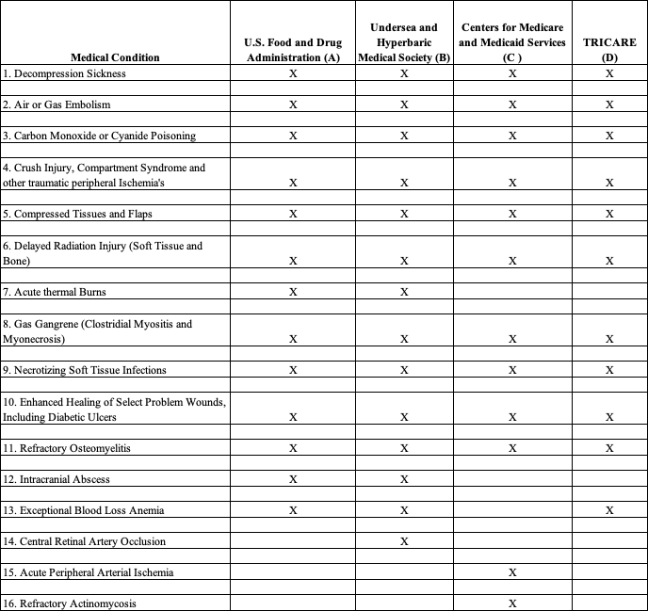
APPENDIX C

Note 1: Column A based on FDA and CDRH Approval of Hyperbaric Oxygen Chamber label, K100268, April 2010, 13 indications
Note 2: Column B based on UHMS Hyperbaric Oxygen Therapy indications 12th ed. December 2008, 14 indications
Note 3: Column C based on CMS, Medicare Coverage Issues Manual Section 35-10, 2002, 12 indications
Note 4: Column D based on Tricare Policy Manual 6010-57-M, Chapter 7, Section 20, February 1, 2008, 11 indications

Kaiser Family Foundation, KFF.org, Medicaid’s Role in Covering Veterans, June 29, 2017
Medicaid & Children’s Health Insurance Program (CHIP) Beneficiaries at a Glance, CMS Medicaid & CHIP Health Care Quality measures, December 2019
Ibid.
Department of Veterans Affairs. (2019). Volume II, Medical Programs and Information Technology Programs, p. VHA-150,

